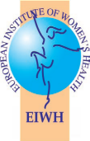
Vaccination—An Almost Forgotten Public Health Protection Measure?

WOMEN AND VACCINATION IN THE EU

The Need for a Life-Course Immunisation Strategy November 2014

In past centuries, infectious diseases were a major health scourge around the globe. Even today, they still pose a serious threat to public health, especially in the developing world. Worldwide, smallpox has been eradicated and polio almost eliminated, except for a few remaining countries. However, there are a number of infectious diseases that continue to plague society worldwide such as malaria, HIV/AIDs, the return of tuberculosis and more recently the Ebola crisis in Africa. Finding effective vaccines for those diseases would have enormous societal and individual benefits of which we can only hope and dream today. Yet despite past successes, today vaccination, if considered at all, is mostly discussed in the context of childhood vaccination, preventing common diseases such as diphtheria, measles, pertussis, rubella, mumps and poliomyelitis (polio) or if there is a scare.

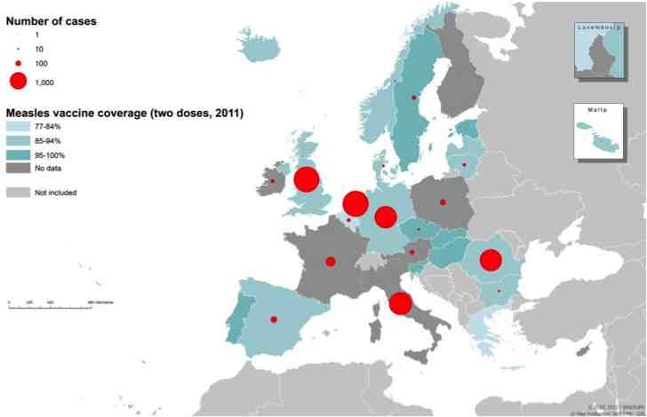
Europeans seem to have forgotten the infectious disease threats of the past and lack awareness and appreciation of vaccination as one of the most effective public health measures available to society to shield against infections. Vaccines protect society and vulnerable individuals who cannot be vaccinated for various medical reasons. Immunisation also protects opponents who refuse to be vaccinated due to their belief. Apart from protecting individuals, vaccination prevents infectious diseases from spreading to vulnerable groups, people with underlying chronic conditions such as asthma, diabetes, pregnant women and older people. In today’s society where the autonomy of the individual is celebrated, it is at times difficult for public health policy and practitioners to find a balance between various conflicting views. Public health policies covering vaccination have to weigh up carefully the rights of the individual against the needs of the community. By necessity a balance has to be struck between different social, cultural, religious norms, beliefs, individual rights and the needs of the community. Failing to do so leaves a dangerous vacuum that has the potential for a future crisis to happen.

Vaccines: The Basics
Currently, there are about twenty
plus vaccines in use worldwide
for diseases such as diphtheria,
haemophilus influenza type b
(Hib), hepatitis B, human
papilloma virus (HPV), influenza,
measles and rubella, mumps,
pertussis, poliomyelitis (polio),
rotavirus, tetanus, tuberculosis,
meningococcal disease
(meningitis and septicaemia)
and invasive pneumococcal
disease (pneumonia and
meningitis). Twenty new or
improved vaccines are
anticipated by 2015. According
to the World Health Organization,
immunisations save more than
three million lives annually. A
further three million deaths
of both children and adults could
be prevented by vaccination. Number of measles cases by country, Nov 2012-Oct 2013 and two doses measles vaccine coverage

How Vaccines and Immunisation Programmes Work
Vaccines cause the immune system to develop antibodies (a blood protein that combats infection) against a specific pathogen (disease-causing virus or bacteria) without infecting the individual with that disease; this process is called “active immunity”. If a person then encounters the disease after having been vaccinated, his/her body will be able to respond straight away developing antibodies to combat it. Vaccines are developed by altering the pathogen in some way, so that the vaccine triggers an immune response without infecting the individual with the disease itself. Vaccines can be created for example by weakening the pathogen, utilising a part of the pathogen or inactivating the pathogen with a toxin. Vaccines may last for a period of time or a lifetime, depending on the vaccine itself.

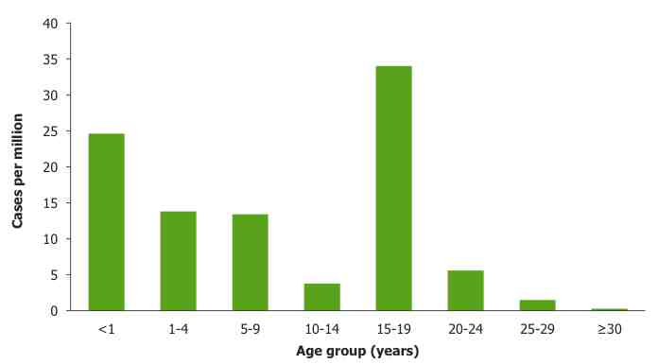
Immunisation programmes aim to protect the at-risk population from a specific disease by offering vaccines to the group. If a sufficient percentage of the population is vaccinated, it is difficult for the disease to spread, even among those who have not been vaccinated. Those who have not received or have refused to be vaccinated are protected by the phenomenon called “herd immunity”. For example in the case of measles, if 95% of the population is vaccinated against this infection, everyone is protected, including the vulnerable and frail, or those who cannot be vaccinated for various reasons. It is clear that in order for vaccination programmes to work, it needs a societal commitment and guidance rather than being solely left in the hands of individual preferences.

Infectious Disease: A Threat
Women and Vaccination in the EU 2 2
in Europe?
Infectious diseases and their
pathogens easily cross borders.
Nonetheless, Europeans have
become “vaccination shy”, no
longer considering such diseases
a problem. In a bizarre way,
vaccination seems to have become
the victim of its own success.

Perhaps this is due to the fact, that
few remember the serious bodily
damage, disability or even death
of the young caused by polio until
the Salk vaccine became available
to all. With major infectious
scourges safely kept under control Rubella notification rate (cases per million) by age group, Nov 2012-Oct 2013,EU/EEA countries
in recent years, chronic diseases
have been the major focus of the European prevention and health promotion policy. This is laudable, but often has to rely on the personal commitment of people to make lifestyle changes, such as stopping smoking, eating a healthy diet, getting adequate physical exercise etc. But whenever possible and available, vaccines should be included as an effective prevention measure for young and old. Take the case of bacterial meningitis and septicaemia; it can kill children and adults. Survivors may become life-long patients suffering from a variety of life-changing expensive-to-treat conditions such as amputations and kidney failure.

Vaccination coverage rates and trust in vaccination are decreasing at an alarming rate across all EU Member States, placing them below vaccination targets and culminating in avoidable and costly outbreaks of communicable diseases in some countries. Recent measles outbreaks in Europe are worrying and should mobilise the public health community into action. Europe has a target of 95 % protection against this infectious disease, but disappointingly has not met the measles-eliminating target set by WHO.

The Need for Vaccination Advocacy
Today, patient advocacy groups are active in most disease areas, from cardiovascular diseases to cancer, rare diseases, Alzheimer’s, Parkinson’s, Multiple Sclerosis, Diabetes etc. These groups are committed to advocating the best treatment for their patients. Yet advocacy for immunisation is sadly lacking. Instead, negative scare stories, such as those linking the measles vaccine with autism in children, long since scientifically refuted, are still circulating. These stories stubbornly prevail and are easily propagated in the social media. Sometimes, young mothers prefer to take their children to playgroups to catch measles “naturally”, rather than have them follow a recommended vaccination schedule elaborated by their national health authorities. Such schedules can be found on the European Centre of Disease Prevention and Control website.

A lack of health literacy has allowed media scare stories, misrepresenting or exaggerating the dangers of vaccines, to create neglect, distrust and even fear of immunisation in the general public. Consequently, vaccination as a primary prevention tool is not high on society’s agenda. The current measles upsurge in some European countries is a warning to policy makers and society alike.

Unless there is positive advocacy for immunisation, together with the political will to support robust, consistent, coherent and evidence-based communication and dialogue by health authorities, trust in vaccination will not be restored and our society will be unable to count on a vaccine- and health-literate public in the case of an emergency or epidemic.

The European Dimension
The European Union (EU) guarantees the free movement of goods, capital, services, and people. Consequently, mobility of people across Europe is on the rise, as increasing numbers of Europeans are living, working and retiring in other member states, bringing with them their pathogens.

The EU Treaty assures citizens a high level of health protection. The European Commission supports Member States in maintaining or increasing rates of immunisation against vaccine-preventable diseases. National health authorities and the European institutions share responsibility for preventing the transmission of emerging pathogens and resurgence of others, as well as having a rapid and coordinated response to infectious threats. However, surprisingly, a comprehensive strategy covering the role of immunisation across the life-course that could potentially also help to mitigate the chronic disease burden over time is lacking.

Vaccination policy and schedules vary greatly across the current EU-28 member states, only adding to confusion and uncertainty, while population coverage has been steadily decreasing in most countries.

Council Conclusions on Childhood Immunisation
The Council Conclusions on childhood immunisation were adopted in June 2011. The Council acknowledges that childhood vaccination falls under the purview of individual Member States but recognises that there is benefit to addressing childhood vaccination across the EU in a coordinated fashion. The Council invites the European Commission, the European Medicines Agency (EMA) and the European Centre for Disease Prevention and Control (ECDC) in collaboration with the World Health Organization (WHO) to improve and monitor vaccination coverage. Moreover, the Council Conclusions encourage the monitoring of public support and development of effective communication messages, including addressing sceptics.

Covering Vulnerable Population Groups—The Case for Preventing Measles Outbreaks
In recent years, there have been alarming outbreaks of measles in various regions of the EU. From 2007-2010, these occurred in countries as far apart as Austria, Bulgaria, France, Germany, Ireland, Italy, the Netherlands, the United Kingdom and Switzerland due to increased levels of susceptible people. In Bulgaria in 2009-2010, measles cases were responsible for 24 deaths and 24,000 cases. In a study of Western Europe, measles treatment cost averaged €209-480 per person while vaccination cost € 0.17-0.97 per person. In 2009, 95% of the reported measles cases in the WHO European Region were from countries in the EU and 65% were from Western Europe.

Life-Course Approach to Vaccination
Infectious diseases are not only a danger to children, but can be a serious health challenge if contracted by individuals at a later age. One of the big challenges in public health is to reach healthy people who could benefit from vaccination but see no need to interact with the healthcare system. Again, there is a lack of awareness of the benefit of vaccination across the life-course and a gap in policy, communication and supportive programmes. As our European societies are ageing, a life-course approach - from childhood, to adolescence, through the middle years to vaccination of older adults - should be taken and the appropriate immunisation programmes for various life stages highlighted and effectively communicated.

Why Are There so Few Advocates for Vaccination?
Chronic disease patient organisations, laudably focused on best treatment and care for their various disease patients, are not always aware of the interaction between chronic and infectious diseases. Patients need to understand that bacterial and virus infections can worsen their already existing chronic condition. Shielding older, or more vulnerable people with chronic diseases from additional infections has the potential to keep frail individuals out of expensive hospital care. For example, patients with asthma and respiratory diseases are at elevated risk of contracting pneumonia or pneumococcal disease, while diabetes patients should be regularly reminded by their health professional to keep their vaccination schedule up to date. The groups who are advocating for vaccination are likely to be orientated toward one specific infection, however they have a significant role to play in joining forces and raising awareness across all target audiences.

The Role of Healthcare Professionals
Awareness and support for vaccination across the life-course ideally should start with General Practitioners (GPs) who typically are the closest to patients, their families and the community. There is an urgent need for strengthening the GP’s role in supporting, facilitating and implementing a comprehensive immunisation policy across the life-course. Medical students, GPs, paediatricians and geriatricians would benefit from training programmes, to enable them to advice their patients routinely. Pharmacists, closely integrated in and respected by their local community could also be mobilised to reach out to the general public, “the healthy well” and patients, as well as practice nurses and midwives, who can reach different population groups. In addition, healthcare professionals themselves, nurses and hospital workers must be mindful and encouraged to keep their own vaccination record up to date.
WOMEN AND VACCINATION IN THE EU 3

Biological (Sex) Variations in Vaccination
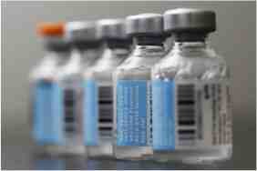
Differences exist between men and women with regard to their immune systems. This aspect still needs to be fully explored. Immune response to infectious disease and consequently vaccination reaction varies. Often, women have a stronger reaction, but reasons for this increased robustness is not fully understood nor exploited by the research and medical community. Researchers are beginning to study biological and gender differences with regard to vaccines. Some speculate that evolutionary differences with respect to trauma exposure may account for the different immune response. Thus research continues to explore why women have much higher rates of certain diseases compared to men, and why some of these same diseases go into remission during pregnancy.

For example, researchers looking at influenza and vaccine have found that immune
response is affected by male testosterone. While the exact mechanism for the
biological sex difference is unclear, testosterone appears to play a role. The
female immune systems tend to have a stronger reaction to the influenza vaccine
than the male system. Men with the highest levels of testosterone appear to have
the weakest antibody response to the vaccine. In future, it may be useful to look
at gender-based differences in the reaction by the immune system. Dosages may
also vary between men and women, which could be a vital vaccine-saving tool
during times of outbreak and/or shortage.
Vaccine vials

Gender Differences and Access to Vaccination
In addition to the biological variation to vaccines response, gender-based social and cultural norms may affect access to vaccination. Women due to their reproductive and caring role often hold responsibility for their children’s health and for the health of older family members and those with disabilities. Yet, in many countries in the world, especially in a male dominated society, women still lack empowerment, financial resources and the autonomy and independence to access immunisation programmes for themselves and their children.

The Global Alliance for Vaccines and Immunisation (GAVI) whose work is mostly directed at immunisation in poor and developing countries makes gender equity an overarching principle in their work. Its gender policy stresses equal access as key to expanding vaccine coverage and making immunisation more equitable. GAVI works together with countries to overcome gender inequities. To qualify for GAVI support, countries are requested to separate data based on gender, income and geographic location to help identify reasons for low immunisation coverage. Importantly, GAVI argues that empowering women is of utmost importance in order to protect children through vaccination.

Differences in vaccination rates exist in countries where women have a low socio-economic status. Their children are less likely to be vaccinated than in countries where women are empowered. Coverage can and should be improved by reducing barriers that women face accessing health services and immunisation for their children.

Women’s Role in Vaccination
Traditionally, women have played an important role in childhood vaccination. It is usually mothers who take their offspring to be vaccinated and ensure that the schedule is kept up to date. In recent years, with the introduction of the HPV vaccines for the prevention of most forms of cervical cancer, mothers and their young daughters have faced the issue of vaccination past childhood into teenage years.

Women are the main carers of children and ageing parents and are therefore more likely to recognise the importance of protecting against infectious diseases. Also due to their own greater longevity, outliving men by an average of 6 years in Europe, women are an obvious group to be engaged by public health experts in a meaningful dialogue about vaccination across the life-course. Women are often involved in or targeted by the anti-vaccination lobby with negative information regarding safety and effectiveness of vaccines, while robust supportive, evidence-based messages about the benefit of vaccination are sadly absent. Health authorities only seem to communicate about vaccination in times of a crisis, missing out vital opportunities to build trust and understanding of vaccination in the general public well before an outbreak starts. Consequently, the lack of effective, consistent, evidence-based public health messages about the benefits of immunisation has allowed misinformation and alarm to fall on fertile ground, nourishing anti-vaccination sentiments by leaving rumour and alarm to spread unfettered.

HPV Vaccination—Preventing Cervical Cancer
WOMEN AND VACCINATION IN THE EU 4
Two different vaccines have been developed to protect against two of the most common (HPV-16 and HPV-18) high-risk cervical-cancer causing strains of HPV that are responsible for 73% of cervical cancer in Europe. The vaccines also provide lower levels of protection against other HPV strains. HPV vaccines are currently aimed at adolescent young girls prior to sexual activity.,

In 2008, the European Centre for Prevention and Disease Control (ECDC) issued a Guidance document for the introduction of the Human Papillomavirus (HPV) vaccines in Europe. In its report of September 2012, ECDC summarised the experience gained from the HPV vaccination programmes during the last four years, including evidence gathered from research studies. , ECDC recommends that routine HPV vaccination should target girls aged between 10-14 before the onset of sexual activity and be administered in three doses within six months. Vaccination of young girls requires the support of parents.

To date, nineteen European countries (in the EU and EFTA) have introduced HPV vaccination: Austria, Belgium, Denmark, France, Germany, Greece, Iceland, Ireland, Italy, Latvia, Luxembourg, the Netherlands, Norway, Portugal, Romania, Slovenia, Spain, Sweden and the UK. Some countries have integrated HPV vaccination into their national immunisation schedules. However, coverage is sometimes low, ranging from 17% to 84%, with only Portugal and the UK having achieved the reported coverage above 80% for the target groups.

Affordability of the HPV vaccine appears to be a major hurdle to implementation across Europe. The ECDC stresses that national screening programmes must be maintained, as HPV vaccination does not eliminate the need for screening, even for women who have been vaccinated. However, existing European screening guidelines will have to be adjusted to determine the necessary interval for PAP smears of already vaccinated women. According to ECDC, randomised trials and observations have demonstrated good safety profiles and efficacy against cervical cancer precursors for the HPV vaccine. The ECDC also examined vaccination of boys as new studies became available. However, ECDC concluded that “vaccinating girls is shown to be more cost-effective than vaccinating boys,” so public health initiatives should continue to focus on vaccinating girls. In future, this policy may be reviewed, if and when more experience is gathered over time.

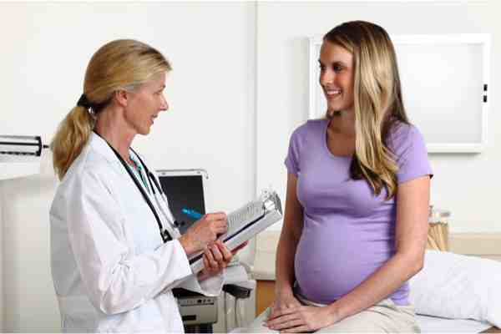
Vaccines during the Reproductive Years
Women and Vaccination in the EU 5 2
Some infectious diseases can cause serious harm
to the pregnant woman and her unborn child.
Pregnant women are a vulnerable population
group. It is important that their immunisation
schedules are up-to-date, ideally before a woman
becomes pregnant, to protect the health of
mother and child. European public health
websites are surprisingly silent on vaccination
during women’s reproductive years, although this
not only affects women themselves but their
offspring and thus the health of the future
generation. For example, in the case of influenza
European data is urgently needed as
most of the scientific advice is based on
non-European data.

The Health Canada website explains that
pregnancy provides an opportunity for evaluating
a woman's immunisation status. The ECDC has Pregnant Woman Consulting with the Doctor
a European vaccination schedule finder on
its website, however, this does not seem to allow searching for pregnancy status. By contrast the New York State Department, the US Centre of Disease Control, and Health Canada provide information on vaccination before and during pregnancy as well as when breast-feeding.

During pregnancy, a women’s immune system is altered, and women are at elevated risk of contracting certain infectious diseases. In addition, the foetus/infant is also particularly vulnerable to certain infections that can be prevented through immunisation. Importantly, if a mother has been vaccinated against infections such as measles, mumps and rubella, her protective antibodies pass through the placenta to her infant; this is referred to as “passive immunity.” The NHS choices website recommends that all pregnant women have the flu vaccine, whatever stage of pregnancy. Historically, studies on immunisation in pregnant and breastfeeding women remain limited. Inactivated vaccines can be given during pregnancy as studies have shown vaccination against tetanus toxoid and the use of the inactivated polio vaccine to be effective and safe. However, active vaccines are generally not recommended to pregnant women due to concerns that they could affect the foetus. Additionally, women are advised not to receive active vaccines less than twenty-eight days before becoming pregnant.,

Protecting Mother and Child Through Vaccination
Vaccines prevent pregnant women from contracting certain infectious disease. Additionally, antibodies are transferred to the foetus, primarily during the third trimester. Antibodies from the mother persist in new-borns for three to four weeks and then decline over six to twelve months. As antibodies decline over time, new-borns should be immunised in order to develop their own antibodies.

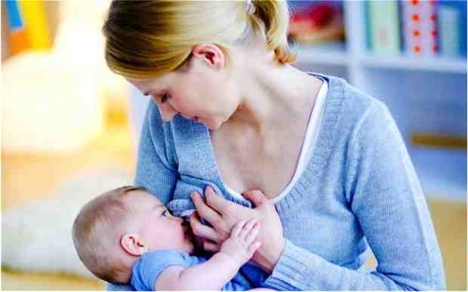
Breastfeeding and Vaccines
Routine inactive vaccines appear to be safe to administer during breastfeeding. The period after delivery and before discharge from hospital offers an opportunity to vaccinate women for their own protection and that of their infants. ,

If the mother is breastfeeding, active vaccines are not recommended, as they may be passed on through the milk to the infant. ,

Woman Breastfeeding

The Ageing Challenge—
WOMEN AND VACCINATIONS IN THE EU 6 5
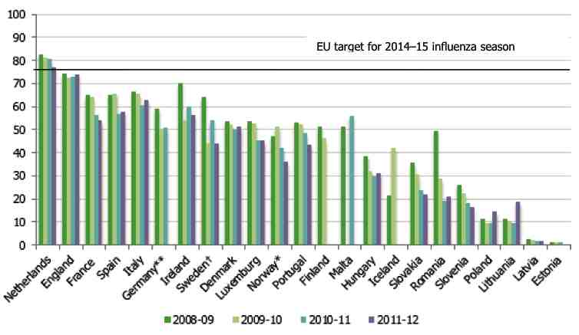
Immunisation Across the
Lifespan

Generally vaccination programmes
in Europe focus on the childhood
years. With an ageing population
comes an ever-increasing burden of
chronic diseases. By 2025, nearly
50% of Europeans will be over 50.
For this age group infections can
be a major cause of illness and
incapacity, if there are underlying
chronic conditions. Pneumonia, remains a
sizeable killer of older people, together
with influenza it accounts for ca. 8%
of all deaths of older people. After cancer,
heart disease and stroke, influenza
it is the 4th most common cause of death,
which peaks during an influenza outbreak.
Seasonal influenza vaccination in older age groups

Vaccination can provide cost-effective protection against a number of diseases throughout the life-course, yet it remains an underused public-health strategy for the promotion of healthy ageing. Life-course immunisation programme can reduce preventable infectious disease and lighten the chronic diseases burden. Several Geriatric societies therefore recommend immunisation of older adults to be promoted as part of active and healthy ageing.

To raise awareness of the health and socio-economic benefits of a life-course approach to immunisation, an informal group of healthcare professional, academics, industry partners, age think tanks, geriatricians, along with patients/health advocates, commissioned a report to support the argument for vaccination across the life-course. The report, entitled “Adult vaccination: a key component of healthy ageing—Benefits of life-course immunisation in Europe,” provides an overview of the state of adult immunisation in the EU Member States and highlights the value of implementing robust policies and programmes from both the public health and macro-economic perspective for the adult population.

Reviewing various EU countries’ healthy ageing strategy and examining existing research as to the incidence of the main vaccine-preventable diseases in Europe, the report reveals current gaps in adult immunisation policies as well as a general lack of public awareness of the health and economic benefit of adult vaccination. Moreover, the group’s report identifies key elements for the successful implementation of adult vaccination and provides practical recommendations for improving rates in older adults.

It appears that the body’s ability to respond effectively to vaccines diminishes with age, which may affect the benefit of vaccination in older people. The British Geriatrics Society recommends developing more effective vaccines and better forms of delivery for older adults (for example, adjuvants and intradermal injections), and at the same time advices that more healthcare workers and carers who come into contact with vulnerable older people are vaccinated against influenza.

Vaccines, Inequalities and Poverty Reduction
The benefit of vaccination reaches beyond the prevention of specific infectious diseases in individuals and has the advantage of protecting all of society, if coverage is sufficiently wide. Vaccination therefore not only makes good medical sense but also is an effective economic measure as it protects the weakest members in society. Large inequities exist throughout Europe and within different countries. Studies indicate that lower socio-economic groups have reduced access to healthcare services and lower vaccination coverage. Coverage also differs between rural and urban settings, minority groups such as the Roma and migrant workers. The gap between Eastern and Western Europe is often due to the cost of vaccination and affordability by health systems. It is important to note that the reasons for being unvaccinated differ significantly from those of being under-vaccinated in Europe. WHO considers immunisation a basic right and a strategic component for reducing poverty. It argues that “immunisations is not only an effective intervention to reduce disease and death, but it can also strategically reduce inequalities in the delivery of primary health care”.

Steps for Action

Women and Vaccination in the EU 7 2

- The Commission, together with EU Member States, to develop a coordinated and comprehensive life-course immunisation strategy to tackle infectious diseases from children to older people including vulnerable groups such as pregnant women, migrants, etc.
Infectious diseases easily cross borders. With the EU’s health policy focus on prevention, the adoption of the Cross Boarder Healthcare legislation and more recently the joint vaccines procurement initiative, the Commission and EU Member States have a solid base to strengthen collaboration and coordination for a common vaccination strategy that protects Europe’s population from infectious diseases.

- To improve vaccination coverage, the Commission together with Member States to engage key civil society organisations, health NGOs and medical professionals to create a health- and vaccine-literate public that understands the benefit of vaccination, herd immunity and the need to play their respective part in protecting individuals and society from infectious diseases.
Currently there is a lack of positive information addressing the general public about the benefits of vaccination. Once there is a disease outbreak, scare stories and rumour are easily spread. It is therefore important for public authorities to invest in consistent, proactive communication before any outbreak takes place. Robust programmes that provide balanced evidence-based information on the benefits and risks of vaccine- preventable diseases create understanding of and trust in immunisation programmes over time.

- Make immunisation once more the norm for society and support positive vaccination advocacy initiatives based on evidence.
The Commission and Member States to engage and involve civil society organisations, health professionals, health NGOs, patient organisations and other key stakeholders, to develop jointly a robust and appropriate vaccination strategy based on best practice for Europe. Health advocacy for communicable diseases is virtually non-existent, therefore encouragement and support for public health vaccination advocacy is urgently needed.

- Support research that explores gender as well as age differences in immunisation and provide advice based on robust European data.
Differences exist between men and women with regard to their immune systems and their reaction to infectious disease. Mechanisms behind variation in immune response should be further studied and more targeted vaccines developed. Gendered socio-cultural differences are important considerations for implementing effective vaccination programmes that reach out and address different population groups.

- Develop communication strategies for immunisation programmes that target older people as part of healthy active ageing.
Infectious disease is the fourth leading cause of death of older individuals. In Europe, women make up the majority of older individuals and comprise most of the group of individuals eighty and older, who often become frail and need care. Preventing infectious disease through immunisation can help to reduce the disability and disease burden facing older people across Europe, thus contributing to making health systems sustainable.

- Encourage research that explores the safety and effectiveness of vaccines during pregnancy and breastfeeding.
Currently, most recommendations on vaccinations during pregnancy and breastfeeding are based on theoretical predictions and data reported from physicians. Research should be funded to better understand the relationship between female reproduction and immunisation to improve the health of mother and child for the benefit of future generations.

- Include the HPV vaccination in cervical cancer prevention programmes.
Revise the Cervical Cancer Prevention Guidelines to adjust for and integrate HPV vaccination. This may potentially bring cost savings to screening programmes and a different screening timetable for already vaccinated women. Involve women’s groups and health NGOs in the process to improve communication and increase uptake of vaccination and cost effective screening programmes.

- Strengthen the role of the ECDC in collecting and sharing consistent and comparable epidemiologic data, disaggregated by age and gender, improve surveillance, as well as making ECDC’s work more visible and widely known across the European Union.

Hildrun Sundseth, EIWH President
Kristin Semancik, EIWH Research and Policy Officer

A warm thank you to our expert reviewers:
Daphne Holt, Ph.D.,
Vice President, Confederation of Meningitis Organisations
Prof J. P. Baeyens
Past President, International Association of Gerontology & Geriatrics, European Region

WOMEN AND VACCINATIONS IN THE EU 8 5
European Institute of Women’s Health, 33 Pearse Street, Dublin 2, Ireland
Telephone: +353-1-671 5691 • Fax: +353-1-671 56 62 • Email: info@eurohealth.ie
Website: http://www.eurohealth.ie

References

WHO. 2014. Vaccine-preventable disease. http://www.euro.who.int/en/health-topics/disease-prevention/vaccines-and-immunisation/vaccine-preventable-diseases.
WHO. 2013. Seven key reasons why immunisation must remain a priority in the WHO European Region. http://www.euro.who.int/__data/assets/pdf_file/0017/84302/Seven_Key_Reasons.pdf.
ECDC. 2013. Surveillance report: measles and rubella monitoring. http://ecdc.europa.eu/en/publications/Publications/measles-rubella-surveillance-oct-2013.pdf
NHS. 2012. How vaccines work. http://www.nhs.uk/Conditions/vaccinations/Pages/How-vaccines-work.aspx.
NHS. 2012. How vaccines work.
NHS. 2012. How vaccines work.
ECDC. 2013. Surveillance report: measles and rubella monitoring. http://ecdc.europa.eu/en/publications/Publications/measles-rubella-surveillance-oct-2013.pdf
ECDC. 2014. Vaccines Schedule. http://vaccine-schedule.ecdc.europa.eu/Pages/Scheduler.aspx.
DG for Internal Policies. 2013. Workshop on Childhood Vaccination and Immunisation. http://www.europarl.europa.eu/document/activities/cont/201306/20130617ATT67963/20130617ATT67963EN.pdf
Council of the European Union. 2011. Council conclusions on childhood immunisations: successes and challenges of European childhood immunisation and the way forward. http://eur-lex.europa.eu/LexUriServ/LexUriServ.do?uri=OJ:C:2011:202:0004:0006:EN:PDF.
WHO. 2013. Seven key reasons why immunisation must remain a priority in the WHO European Region. http://www.euro.who.int/__data/assets/pdf_file/0017/84302/Seven_Key_Reasons.pdf.
International Longevity Centre. 2011. Life course immunisation: improving adult immunisation to promote active ageing. http://www.google.com/url?sa=t&rct=j&q=&esrc=s&source=web&cd=2&ved=0CDMQFjAB&url=http%3A%2F%2Fwww.ilcuk.org.uk%2Ffiles%2Fpdf_pdf_190.pdf&ei=3abdUu2hGumO7QbLzoGwDQ&usg=AFQjCNFuROwOo22SpooLikmGgoNDl2T0fQ&bvm=bv.59568121,d.ZGU.
David Furmana, Boris P. Hejblumb, Noah Simonc, Vladimir Jojicd, Cornelia Dekkere, Rodolphe Thiébautb, Robert J. Tibshiranic, and Mark M. Davisa. 2013. “Systems analysis of sex differences reveals an immunosuppressive role for testosterone in the response to influenza vaccination.” Proceedings of the National Academy of Sciences of the United States of America. http://www.pnas.org/content/early/2013/12/20/1321060111.abstract?sid=05e36f1c-942c-4eb2-a06b-66d37b6ec93e.
David Furmana, et al. 2013. “Systems analysis of sex differences reveals an immunosuppressive role for testosterone in the response to influenza vaccination.”
Hatch. 2013. Influenza Vaccine Safe. http://www.pregnancyandbaby.com/the-hatch-blog/articles/966069/study-deems-flu-vaccine-safe-in-pregnancy
Global Alliance for Vaccination and Immunisation (GAVI Alliance). 2012. Gender-related barriers to vaccination. http://www.google.com/url?sa=t&rct=j&q=&esrc=s&source=web&cd=1&ved=0CCkQFjAA&url=http%3A%2F%2Fwww.gavialliance.org%2Flibrary%2Fdocuments%2Fgavi-documents%2Fguidelines-and-forms%2Fhss-information-note---gender-related-barriers-to-vaccination-services%2F&ei=fXTeUrOnC6PF7AbMgIHoDA&usg=AFQjCNFkzqxT3J7dZAk07LcrcIQNrtqi6w&bvm=bv.59568121,d.ZGU.
GAVI Alliance. 2014. Gender and immunisation. http://www.gavialliance.org/about/mission/gender/.
European Cervical Cancer Association (ECCA). 2009. HPV Vaccination across Europe. http://www.ecca.info/fileadmin/user_upload/HPV_Vaccination/ECCA_HPV_Vaccination_April_2009.pdf
European Centre for Disease Prevention and Control (ECDC). 2008. Guidance for the introduction of HPV vaccines in EU countries. http://www.ecdc.europa.eu/en/publications/publications/0801_gui_introduction_of_hpv_vaccines_in_eu.pdf.
ECDC. 2008. Guidance for the introduction of HPV vaccines in EU countries.
ECDC. 2012a. Introduction of HPV vaccines in European Union countries—an update. http://ecdc.europa.eu/en/publications/publications/20120905_gui_hpv_vaccine_update.pdf.
ECDC. 2012b. ECDC guidance on HPV vaccination: Focus on reaching all girls. http://www.ecdc.europa.eu/en/press/news/_layouts/forms/News_DispForm.aspx?ID=497&List=8db7286c-fe2d-476c-9133-18ff4cb1b568.
ECDC. 2012a. Introduction of HPV vaccines in European Union countries—an update.
Public Health Agency of Canada. 2013. Canadian Immunisation Guide.
Fox News. 2013. Flu outbreak. http://www.foxnews.com/health/2013/01/10/flu-outbreak-why-are-so-many-not-getting-vaccinated/
http://vaccine-schedule.ecdc.europa.eu/Pages/Scheduler.aspx
Public Health Agency of Canada. 2013. Canadian Immunisation Guide. “Part 3: Vaccination of Specific Populations.” http://www.phac-aspc.gc.ca/publicat/cig-gci/p03-04-eng.php.
NHS. 2012. How vaccines work.
NHS. 2012. The flu jab in pregnancy. http://www.nhs.uk/Conditions/pregnancy-and-baby/Pages/flu-jab-vaccine-pregnant.aspx
Public Health Agency of Canada. 2013. Canadian Immunisation Guide.
Mayo Clinic. 2013. Vaccines during pregnancy: are they safe? http://www.mayoclinic.org/vaccines-during-pregnancy/expert-answers/FAQ-20057799.
Public Health Agency of Canada. 2013. Canadian Immunisation Guide.
Public Health Agency of Canada. 2013. Canadian Immunisation Guide.
New York Department of Health. 2013. Vaccinating women of reproductive age recommendations and guidelines. http://www.health.ny.gov/prevention/immunisation/vaccinating_women_of_reproductive_age_guidelines.htm.
Public Health Agency of Canada. 2013. Canadian Immunisation Guide.
New York Department of Health. 2013. Vaccinating women of reproductive age recommendations and guidelines. http://www.health.ny.gov/prevention/immunisation/vaccinating_women_of_reproductive_age_guidelines.htm.
Telegraph. 2012. “Boosting breastfeeding rates saves lives and money.” http://www.telegraph.co.uk/health/healthnews/9614658/Boosting-breastfeeding-rates-saves-lives-and-money-Unicef.html
ECDC. 2009. Implementation of the Council Recommendations on the seasonal influenza vaccination. http://www.ecdc.europa.eu/en/publications/Publications/Implementation-seasonal-influenza-vaccination-Council-Recommendation-Jan-2014.pdf
British Geriatrics Society. 2011. Vaccination programmes in older people—BGS best practice guide..http://www.bgs.org.uk/index.php/topresources/publicationfind/goodpractice/1158-vaccinationbpg.
ILC http://www.ilcuk.org.uk/index.php/publications/publication_details/adult_vaccination_a_key_component_of_healthy_ageing
British Geriatrics Society. 2011. Vaccination programmes in older people—BGS best practice guide.
WHO. 2013. Seven key reasons why immunisation must remain a priority in the WHO European Region. http://www.euro.who.int/__data/assets/pdf_file/0017/84302/Seven_Key_Reasons.pdf.

