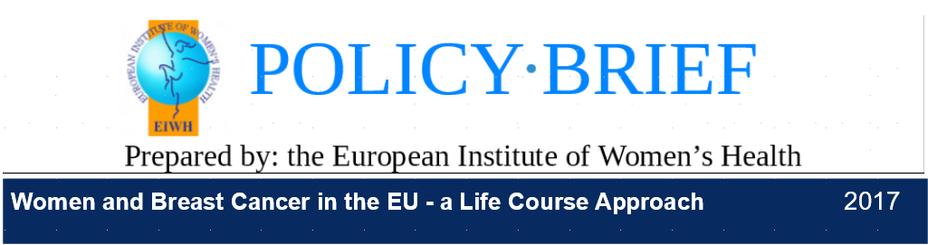
Overview
Cancer rates continue to rise globally and are projected to nearly double by 2030, taking a huge toll on patients, their family members, friends and carers.i,ii Large strides have been made to reduce the burden of cancer in Europe through improved screening and treatment.
Despite improved efforts, breast cancer remains the leading cause of cancer death for women throughout the world in both developing and developed countries.iii In 2012, there were about 459,000 new cases of breast cancer in Europe and 131,000 deaths from the disease. The rate of new cases of breast cancer in Western Europe is among the highest in the world; one in every eight women in the EU will develop breast cancer before reaching the age of eight-five.iv Breast cancer accounts for 29% of new cancers and 17% of cancer deaths for women in the EU. As Figure 1 illustrates, large variations persist across Europe with regard to breast cancer incidence rates (new cases per year) and mortality (deaths per year). In 2009, cancer cost the EU Member States approximately €126 billion, with breast cancer accounting for about 12% of this the total expenditure.v
Breast Cancer: The Basics
Breast cancer occurs when there is abnormal growth in breast cells and it can originate in different parts of the breast.vi There are various types of breast cancer with each one referring to the type of cell where the abnormal growth comes from:vii,viii,ix
Milk ducts (ductal carcinoma): Milk ducts carry milk from the lobules (where milk is made) to the nipples. Breast cancer occurring in the ducts is referred to as “ductal carcinoma.” This type of cancer is the most common type of breast cancer occurs in the lining of the ducts. This tumour can be a non-invasive within the ducts (ductal carcinoma in situ) or spread beyond the ducts (invasive ductal carcinoma).x,xi
Lobules (lobular carcinoma): Breast milk is produced in the lobules of the breast. Breast cancer developing in the lobules is called “lobular carcinoma.” Invasive lobular cancer occurs when cancer spreads beyond the lobules. xii,xiii
Connective tissue (sarcomas): Connective tissue of the breast is made up of the blood vessels, fat and muscle of the breast tissue. Breast cancer that develops in this connective tissue is categorised as “sarcomas” of which there are multiple types. This type of breast cancer is rare and there are additional rare forms.xiv,xv
Breast cancer can be divided into various stages using the tumour, node, and metastasis (TNM) categorisation, a coding system for cancer staging. Stages describe the size of the cancer and whether or not it has spread to other parts of the body. The staging is used for treatment decisions:
• Tumour (T): T describes the size of the tumour xvi
• Node (N): N indicates whether (or not) and to what extent the tumour has spread to the lymph nodes xvii
• Metastasis (M): M specifies whether or not the tumour has spread to other areas of the body, such as the bone, brains, liver or lungs.xviii,xix
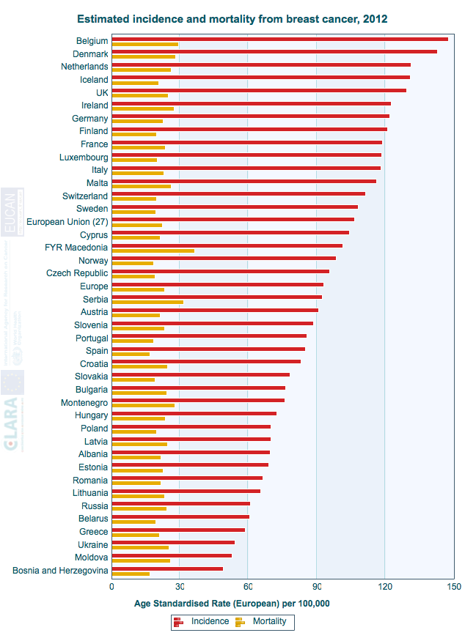
Figure 1: New cases of and death from breast cancer in Europe in 2012 xx
Metastatic breast cancer (mBC) is the most advanced stage of breast cancer and occurs when the cancer spreads to other parts of the body. About 5-10% of new breast cancer diagnoses are metastatic. xxi Women diagnosed with mBC on average live two to four years. xxii Only about one in five women (22%) with mBC will survive more than five years. xxiii The average women with mBC will receive eight to ten courses of treatment to try to slow the disease progression, however mBC currently has no known cure.
The grade of breast cancer relates to how abnormal the cells appear when viewed under a microscope and provides some indication of how the cancer may behave. Breast cancer grades can range from low to intermediate to high. Low grades are generally slower growing than are high-grade breast cancers. High-grade cancers are more likely to come back than low-grade breast cancers.xxiv,xxv
There are various other indicators for how someone will respond to the cancer and treatment. For example, patients with hormone receptor positive status tumours—the most common type of breast cancer whereby a tumour pick-ups up signals to grow from the hormones oestrogen and/or progesterone—generally respond well to hormonal treatment. Such tumours are less aggressive than ones that do not respond to these signals. Similarly, women with BRCA gene mutations are not only more likely to develop breast and ovarian cancers, but have a lower survival rate than women without such mutations. Additionally, the HER2 gene—a gene that influences the proteins on the cell’s surface controlling the tumour’s growth—affects breast cancer prognosis. HER2-positive breast cancers are more aggressive and more likely to spread than those where the gene is not present. Age also affects prognosis; women under the age of 35 typically have more aggressive breast cancer than older women.xxvi
The various types of breast cancer have implications for both patients and their caregivers. For example, inflammatory breast cancer (IBC) occurs when breast cancer cells block the lymph channels, resulting in reddening and inflammation of the skin.xxvii IBC is one of the less common types of breast cancer, accounting for about 1-2% of breast cancers, but it can grow more quickly and spread to other parts of the body than other types of breast cancer.xxviii Treating this type of cancer requires expert care at specialised breast cancer centres which are not available everywhere in Europe.
Another type of cancer, locally advanced breast cancer (LBAC), occurs when breast cancer spreads to the lymph nodes near the breast, chest wall or breast skin, but has not yet spread to distant organs.xxix This type of breast cancer requires expert daily care and there is often limited information available to patients from online sources Although both IBC and LBAC make up a small percentage of total breast cancer patients, they demonstrate some of the important and diverse needs for both patients and carers.

Breast Cancer Risk Factors
There are various risk factors that studies have found to be associated with developing breast cancer including:xxx,xxxi
- Being a woman
- Being older (over age 50)
- Family history of breast cancer
- Genetics (BRCA1, BRCA2 and other genes)
- Personal history of breast cancer
- Personal history of cancer
- Hormones
- Birth control use
- Hormone Replacement Therapy (HRT) use
- Starting menstruation before the age of 12
- Dense breast tissue
- Starting menopause after the age of 55
- Drinking alcohol
- Being overweight or obese
- Physical inactivity
- Not having children or having children after the age of 30
- Chest radiation exposure
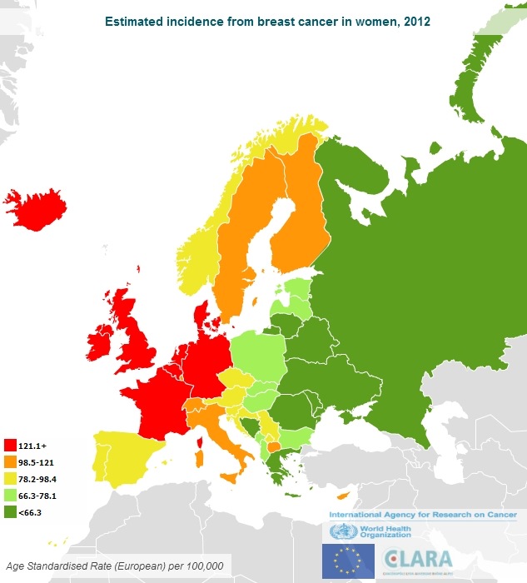
Figure 2: New cases of breast cancer in Europe in 2012 xxxii
Some steps can be taken to reduce the risk of breast cancer. Known risk factors should be avoided, including but not limited to unhealthy diet, alcohol, and prolonged use of hormone replacement therapies (HRT). Women should exercise regularly. Breastfeeding should also be encouraged.xxxiii,xxxiv
For some risk factors, a prevention strategy may not be possible. For example, if the individual has a genetic predisposition. It these circumstances, it is important for modified and/or tailored prevention strategies to be developed for those who are at risk. In addition, awareness of and information on diagnostics and management services must be provided.

As Figures 2 and 3 illustrate, the highest rates of new cases of breast cancer occur in Northern and Western Europe, yet the highest death rates from breast cancer are in Eastern Europe, illustrating the large health inequities across Member States. Studies exploring the link between race, ethnicity, and breast cancer have primarily taken place in the United States. However, recent studies indicate that variation in breast cancer by race and ethnicity occurs in a European context as well with differences in age of diagnosis and post-diagnosis outcomes. Given the increasing diversity in the European population, race and ethnicity are important to consider in breast cancer research, prevention, screening, diagnosis, treatment, and follow-up.xxxv
Breast Cancer Risk Factors (continued)
In addition, socio economic status affects breast cancer development and mortality. In Europe, higher socio economic status has been linked to an elevated rate of breast cancer compared to those in lower socio economic status. Differences based on socio economic status may occur for a variety of reasons including lifestyle, hormone replacement therapy (HRT) usage, mammography screening use, and reproductive factors. However, women of higher socio economic status have lower rate of death from breast cancer than do those from lower socio economic statuses. As Figure 4 illustrates, women of lower socio economic status have a lower screening attendance than do those of higher socio economic status. Delayed diagnosis can have severe repercussions for breast cancer treatment and outcomes. xxxvi
Breast Cancer Screening—An Important Tool in Prevention
Breast cancer screening typically involves the use of mammography (an x-ray of the breast) to look for early signs of breast cancer. When breast cancer is caught early, treatment is more likely to be successful. Population-based screening programmes offer testing to an entire target age group in order to detect breast cancer at an early stage. Existing recommendations are for regular mammography screening in women ages 50 to 69.xxxvii
The benefits of the existing recommendations have been balanced against the risk of radiation exposure, false positives, and over-diagnoses in order to develop robust, effective, and equitable breast cancer screening programmes. In 2016, the International Agency for Research on Cancer (IARC) and subsequent studies found that the benefit of breast cancer screening solely through mammography was sufficient for women 50 to 74 years of age; limited for women 40 to 49 years of age; and inadequate for women younger than 40 or older than 69 years of age.xxxviii,xxxix
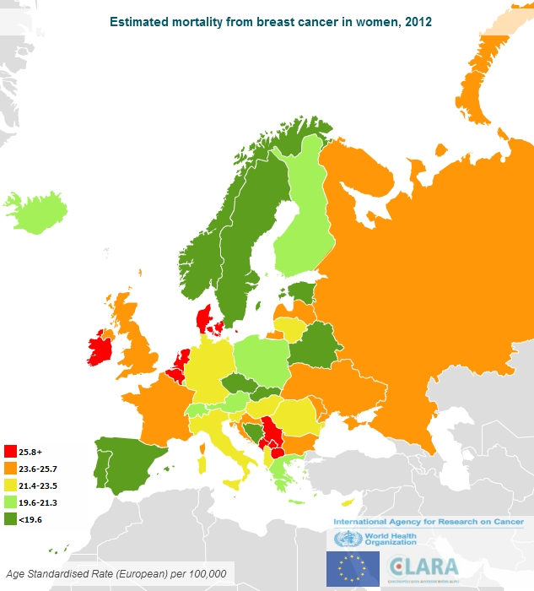
Figure 3: Death from breast cancer in Europe in 2012 xl
Although less common in younger demographics, pre menopausal women diagnosed with breast cancer have more aggressive breast cancer and lower rates of survival than do older women; these women are not captured under the current screening guidelines.xli,xlii Recent studies conducted by Harvard University have reaffirmed the importance of breast cancer screening—the research found that more than 70% of breast cancer deaths were among the 20% of people who did not participate in screening.xliii However, countries still faces the challenge of encouraging all women in the target group to attend organised screening programmes. In particular, mobilising vulnerable groups of women remains a challenge.

Breast Cancer Diagnosis and Treatment
Breast cancer can be detected using a variety of methods. The breast and lymph nodes can be checked in a breast exam. A mammogram is commonly used to detect breast cancer and further testing can be required depending on the results. A breast ultrasound (sound wave imaging) or breast MRI (magnet and radio imaging) can be used in diagnosis. A biopsy—when samples of breast tissue are removed for testing—can be used to definitely determine if cells are cancerous as well as to determine the type, grade, and hormone receptivity of any cancer that is found.xliv
Treatment for breast cancer involves attempting to stop the spread of the cancer and where possible removing cancerous cells. Treatments vary by the tumour size, type of cancer, and its location. Surgery, radiotherapy, hormone therapy, targeted therapies, and chemotherapy can be used on their own or in combination. Local treatments—surgery and radiotherapy—only treat the affected cancer areas. Surgery is typically the first type of treatment. Systematic treatments—chemotherapy and hormone therapy—treat the whole body.xlv, xlvi Breast cancer treatments have a range of side-effects, some of which (depending on the treatment) are particularly pronounced.
Age and Breast Cancer
Age is another important factor in understanding the development, diagnosis, treatment, and outcomes of breast cancer. Most breast cancer occurs in women ages 50 and older. About 20% of breast cancer occurs in women under the age of 50 years, 37% in ages 50-64, and 43% in women over the age of 65.xlvii By the age of 85, women have a 12% risk of developing breast cancer.xlviii
Breast Cancer and Young Women
Breast cancer in women under the age of 40 is relatively rare. However, women who develop breast cancer under the age of 40, especially those under the age of 35, are at an elevated risk of having more aggressive breast cancer requiring intensive treatments. Consequently, this group may have more severe side-effects that affect their quality of life. Compared with older women breast cancer in younger women tends to be more aggressive, of higher grade, and oestrogen receptor-negative (a characteristic of the cancer that limits the range of treatments available).xlix,l
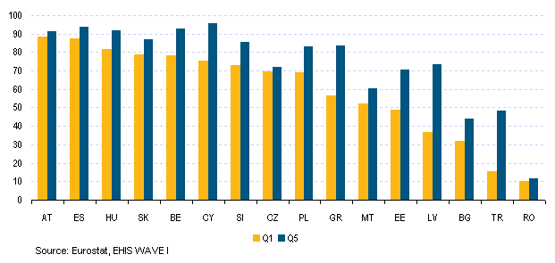
Figure 4: Participation in mammographic screening (women aged 50-69) by income, lowest income (bottom 1/5) and highest income (top 1/2008)
As younger women have higher breast density, standard breast cancer screening techniques for this group are less effective and are not recommended unless the woman is at particularly high risk of developing breast cancer (for example, where there is a genetic predisposition). Thus, breast cancer in younger women must be managed differently than it is in older women and particular attention has to be devoted to preventing relapse. Breast cancer can have large implications for younger women’s fertility, mental health, careers, and families.li, lii Studies from the United States indicate that the rates of mBC are increasing among young women although they have not increased in women over the age of 55 over recent decades, which warrants more investigation, particularly to determine if a similar trend is apparent in a European context.liii
Breast Cancer and Older Women
Research has also found that older women (women over the age of 70), are twice as likely to die from breast cancer compared with those patients under the age of 70. Similarly, chemotherapy effectiveness levels have been found to be lower for women over the age of 75 .liv Moreover, older women have been found to be offered breast cancer surgery less than are their younger counterparts. Breast cancer surgery for women ages 60 to 80 is only advised when there are no or few co-morbidities as surgery can present major risks to the patient. There are discrepancies in diagnosis and prognosis of older women with breast cancer across Member States. For example, older women in England are three times more likely to die of breast cancer compared with the same cohort in other European nations.lv

It is important to study why surgery and chemotherapy are not recommended more often to older women. These treatments may adversely impact their independence and quality of life, and increasing awareness of current geriatric oncology guidelines while enabling oncologists to present choices to their patients. Research, including patient surveys, should be carried out to identify how best to treat and support older women with breast cancer. Discrimination towards older patients should be explored and systematically addressed. Therefore, age can be one important factor in breast cancer treatment and should be considered in conjunction with other factors.
Breast Cancer and Depression
Breast cancer increases the risk of depression. Up to 40% of breast cancer patients experience depression and anxiety, with the highest rates of depression occurring in the first year after diagnosis. Overall, breast cancer diagnosis increases the risk of depressive disorders in between 10% to 30% of women, with the increased risk of development at its highest in the year following diagnosis. lvi The rates of depression in women with mBC appear to be especially elevated and warrant further investigation.lvii Some studies suggest over 25% of those with advanced cancer develop depression.lviii
Chemotherapy, asymmetry following breast surgery, and side-effects from breast cancer treatment are significant risk factors for breast cancer-related depression. Depression also increases the risk of poor adherence to breast cancer treatment, impacting on prognosis. Women with mBC with fewer depression symptoms have longer survival rates.lix However, recent studies indicate that some anti-depressants may reduce the effectiveness of tamoxifen, an endocrine therapy.lx Depression in those with breast cancer remains under diagnosed and under treated lxi and warrants further investigation and intervention.
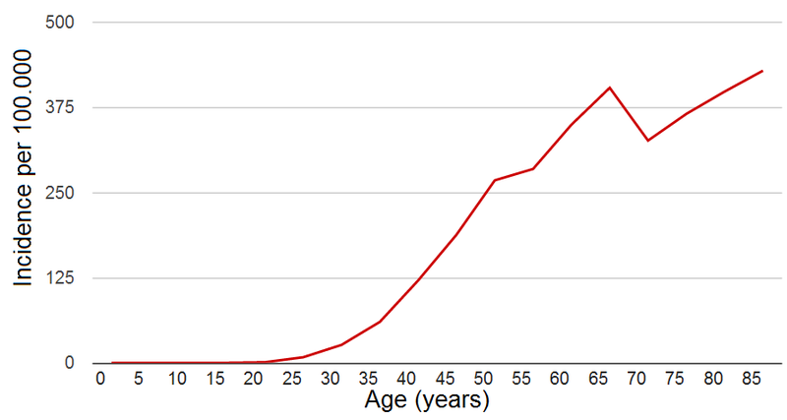
Figure 5: New Cases of Breast Cancer per Year, UL, 2006-2008 lxii
Breast Cancer Employment, Care and Support
The ability to continue working with breast cancer varies depending on the type of cancer, the treatment, individual health, and the type of work. Some women continue to work full-time during treatment, while others adjust their work arrangements depending on employer accommodation. Others are too tired or sick to work.lxiii Studies from the US have shown that breast cancer has a significant impact on patients’ careers by reducing employment, working hours, and income.lxiv
Most cancer patients bear additional costs due to their cancer diagnosis, including medical, prescription, and travel costs. Utility bills may also increase as the patient may be at home more during treatment. Most patients also need to take time off from work during and/or after treatment. The extra costs of breast cancer coupled, with the decreased income can lead to financial difficulty for breast cancer patients. As a result, financial stress and strain may develop. Patients may be forced to take out loans, reduce other expenditures, or may fail to pay bills.lxv The financial burden of cancer can cause “financial toxicity” for the patient and his/her family. This problem is particularly pronounced when the patient and/or their family members are unemployed or working in temporary positions during treatment and recovery.lxvi

Breast cancer patients and survivors can face discrimination from their employers. As a result, women may make decisions about treatment in order to retain their job or from fear of prejudice, to the detriment to their health. This discrimination is particularly pronounced for women who are managers and entrepreneurs. Employers should make efforts to reduce these barriers so that breast cancer patients and survivors are supported in the workplace through work adjustments during treatment and recovery.lxvii,lxviii
In addition, most patients with breast cancer receive informal care from their families and/or close friends. This caring burden disproportionately falls on women and girls. Informal caregiving has large social, emotional, financial, and physical implications, but a lack of data regarding this phenomenon warrants further investigation in Europe. Caregiver support varies significantly throughout the EU lxix, and there is a necessity for institutional recognition of the role.
Breast Cancer Survivorship: Life After Treatment
The long-term survival rate of those with breast cancer is increasing. Over 80% of breast cancer patients are cancer-free after ten years.lxx Cancer survivorship plans are important to empower cancer survivors to interact more forcefully with healthcare professionals. Breast cancer is considered “cured” without recurrence after ten years. Consequently, long-term survivors then face challenges with respect to who to consult after the ten-year survivor mark.
However, recurrence always remains a concern for breast cancer survivors. Of women with early stages of breast cancer (breast cancers that had not spread to other parts of the body beyond the lymph nodes lxxi), 20-30% will develop mBC. Eighty-percent of breast cancer recurrence occurs within five years of the initial diagnosis. Survivors who have finished treatment and are cancer-free require regular follow-up, including clinical visits, and mammography.lxxii
Patients with mBC face unique challenges. As mBC is currently treatable but nevertheless incurable, those with mBC will be in treatment for the rest of their lives and require particular support and care for their physical and mental health needs, as these patients may feel isolated and alone. The uncertainty of recurrence can also have an impact on women’s mental health.lxxiii,lxxiv
In addition, breast cancer has implications for family dynamics, with carers and patients’ families in need of psychosocial support. There is a lack of readily accessible resources for mBC patients and their carers, which must be addressed as a matter of urgency.
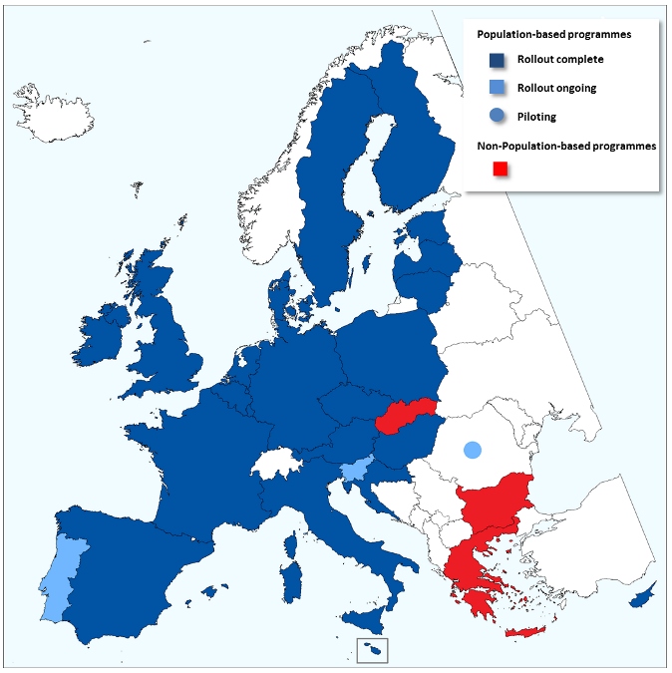
Figure 6: Distribution of Breast Cancer Screening Programmes in the EU, 2016 lxxv
The past and current treatment of breast cancer survivors has long-term health implications that must be considered and managed by their doctors and healthcare support teams. Long-term, breast cancer survivors may have hot flushes, fatigue, chronic breast pain, lymphedema (swelling of arms and legs), loss of sex drive, and fear of recurrence. Breast cancer increases the risk of obesity, high blood pressure, , high cholesterol, and diabetes later in life. Breast cancer can have long-term effects on fertility and sexuality.lxxvi,lxxvii In addition, breast cancer treatments may impact on cardiovascular health, bone density, and quality of sleep.

The European Union Dimension on Cancer Screening
In order to reduce the burden of cancer across Europe, the European Council Recommendations on Cancer Screening called on its Member States to implement effective screening programmes for breast cancer, cervical cancer, and colon cancer. These recommendations prescribe population-based breast cancer screening programmes, employing mammography for women ages 50 to 69.lxxviii Progress reports have evaluated national-level implementation of the 2003 recommendations and subsequent EU programmes, including the most recent in 2017. lxxix As of 2007, 22 of 27 EU Member States were setting-up or running population-based breast cancer screening programmes. By 2016, 25 of the 28 Member States had established programmes or programmes in development.lxxx
In response to these recommendations, various European initiatives have sought to promote cooperation in order to more effectively combat cancer in the EU. The Joint Actions on Cancer— European Partnership for Action Against Cancer (EPAAC) and European Guide on Quality Improvement in Comprehensive Cancer Control (CanCon)—have brought together key stakeholders to collaborate on preventing and improving cancer control throughout Europe. In 2006, the European Commission published the 4th edition of the European Guidelines for Quality Assurance in Breast Cancer Screening and Diagnosis to improve the quality of breast cancer screening programmes by highlighting best practice. The Council Conclusions on reducing the burden of cancer, published in 2008, call on the Commission to develop a pilot accreditation scheme for breast cancer screening. The European Commission Initiative on Breast Cancer (ECIBC) works to improve national programmes and to increase Member State collaboration in order to improve and to harmonise breast cancer screening programmes through efforts such as quality assurance. The European Commission also created the Expert Group on Cancer Control in 2014 to evaluate the existing evidence and assist the European Commission in the policymaking process.
Healthcare delivery systems, including cancer-screening programmes, remain a national competency in the European Union. The EU continues to work to foster cooperation, share information, and improve the existing evidence base through non-binding policies and programmatic support that complement national policies, such as the Council Recommendations of December 2003. The European Cancer Registry Network—which has been in operation since 1990—promotes collaboration among the national registries. However, there is no supranational mandate to harmonise cancer screening. These health programmes remain under national control and much data, such as the tracking of progression, are not included.

2003 Council Recommendation on Cancer Screening
The 2003 Council Recommendation on Cancer Screening calls on EU Member States to put breast, cervical, and colorectal cancer programmes in place for early detection of these cancers. Although the recommendation is not binding, it encourages Member States to develop effective screening programmes.
National Policy and Practice in Europe in Screening
Comprehensive national cancer screening programmes are essential to diagnosing breast cancer. Mammography screening has proven to significantly reduce mortality from breast cancer by detecting it at an earlier stage. Well-organised national screening programmes can reduce breast cancer death in women over the age of fifty by at least 20%. However, about 30% of women diagnosed with breast cancer at an early cancer stage will develop recurrent advanced or metastatic breast cancer despite effective screening efforts.lxxxi
Population-based breast cancer screening programmes began in the 1980s in Sweden (1986), Finland (1987), UK (1988), and the Netherlands (1989). 26 Member States currently have regional or national registries, which support the cancer control programmes by tracking data. As of the most recent progress report, 25 of 28 Member States are either planning, piloting, or rolling out population-based breast cancer screening programmes or had already established them (see Figure 6). Eligible women receive screening every two years in most programmes (screening is very three years in Malta and the United Kingdom). Bulgaria, Greece, and Slovakia have non-population-based programmes, and Romania has a small pilot at the moment (see Figure 7).lxxxii, lxxxiii
The coverage of these screening programmes varies across Member States. The highest participation rate for women ages 50-69 was in Denmark (84%) and the lowest in the Wallonia region of Belgium (6%). On average, the EU did not reach the target level of 70% population coverage, with several countries failing to do so due to educational, organisational, and other barriers.lxxxiv,lxxxv Large inequities in screening therefore remain within many European countries.lxxxvi A key challenge is how to reach out to socio-economically disadvantaged women.

The Irish Case
Following the successful Pilot Eccles Breast Screening Programme in Ireland in the 1990s, the Steering Group and Quality Assurance Committee explored the creation of a national programme in 1997. Ireland began BreastCheck, the National Breast Cancer Screening Programme, in 2000 for women ages 50 to 64. The programme began in the east of the country and expanded over time. In 2005, BreastCheck was extended nation-wide, utilising both designated hospital and mobile units. BreastCheck is currently extending the screening age; women between the ages of 50 and 69 will be invited for a free mammogram every two years by 2021. There has been a recent increase in breast cancer screening uptake. From 2013 to 2014, the uptake rate in the target population increased from 70.2% to 76.5%, surpassing the 70% programme target. The programme has provided more than 480,000 women with 1.37 million mammograms, detecting 8,500 cancers by the end of 2014.lxxxvii,lxxxviii In order to track cancer trends, the Irish National Cancer Registry has been collecting data on cancer incidence, treatment, and survival in Ireland since 1994. The Registry carries out research to improve cancer outcomes and to reduce the cancer burden. The comprehensive data gathered could be utilised more effectively to develop better services to support the needs of patients and survivors. In 2006, Ireland published its National Cancer Control Strategy in order to prevent, diagnose, and treat cancer. In 2015, Steering Group was created to develop a new strategy. Over the last three decades, Ireland has witnessed a reduction in breast cancer mortality of roughly 40%.lxxxix,xc
Current State of European Data
Cancer registries collect, manage, and analyse data on those with cancer in designated regions or in countries. The first cancer registry began in Hamburg, Germany in 1926. European-wide cancer registries began in the 1950s and 1960s. There are about 160 cancer registries in Europe at present covering about 72% of the population in the EU.xci The European Commission’s Europe Against Cancer Programme created the European Network of Cancer Registries (ENCR) in 1990 in order to foster collaboration between cancer registries, to train cancer registry personnel, to set standards for data collection, and to disseminate cancer data in Europe.xcii With funding from the European Commission, the International Agency for Research on Cancer (IARC) in partnership with the ENCR developed the European Cancer Observatory (ECO), a system of information on the burden of cancer in Europe.xciii

Recently, the ENCR Secretariat moved to the European Commission’s Joint Research Centre, but no updated information on breast cancer burden from the Europe-wide cancer registry data has become available.xciv The most recent data from cancer registries, available on the ECO website, covers up to the 2007/2008 period. The GLOBOCAN Project has more recent breast cancer estimates; however, these are estimates rather than register-based data from several countries, which do not provide reliable information on breast cancer trends.xcv The WHO mortality database also includes data on breast cancer, however this is not linked to the cancer registry, age, time, stage, etc. at the time of diagnosis. The mortality database only includes age and time of death from breast cancer not information with respect to the breast cancer diagnosis or progression.
The current registries collect a lot of information on breast cancer, including age, grade, and diagnosis date. However, there are limitations on the data available on breast cancer in Europe. Specifically, the data collected by cancer registries continues to vary by country. Moreover, much of the information collected is not compulsory. Additionally, not all countries track stage and treatment at diagnosis. Others do not have accurate survival calculations due to a lack of access to death certificates. In addition, not all capture information on survey, follow-up and co-morbidities. In various countries, the cancer registry is not linked to screening data. Thus, the standardisation and coverage of data must be improved. xcvi
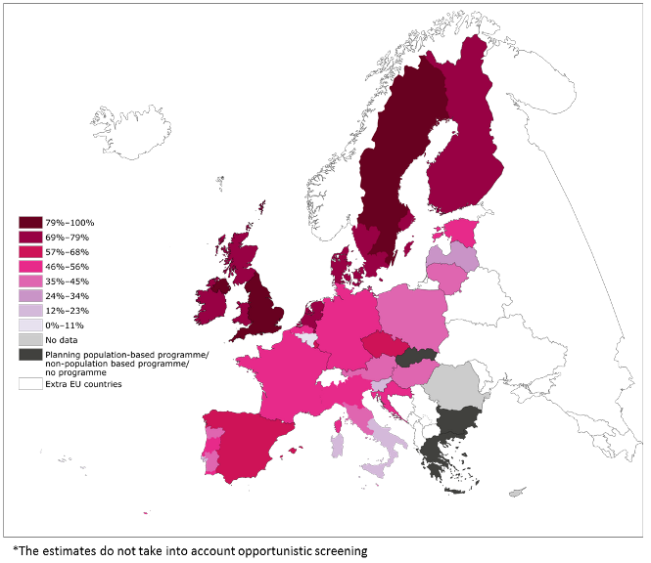
Figure 7: Breast Cancer Screening Programmes in coverage ages 50-69 years, 2013 xcvii

1) Targeted research must be conducted by age, race/ethnicity and type of breast cancer in order to increase the understanding of the development, prevention, diagnosis, progression, and treatment of breast cancer.
Efforts must be made to better understand the development, prevention, progression, treatment, and prevention of breast cancer, including metastatic breast cancer (mBC) by employing a life-course approach from young through older age. Research must not only explore the biological aspects of breast cancer, but must also explore the mental, social, and economic implications for those with the disease as well as for those who survive it. Research must be conducted to better understand the influence of race and ethnicity on breast cancer in a European context.
2) In order to improve existing practice and policy, breast cancer data must be disaggregated based on various factors, including age and cancer stage. A robust, comparable monitoring system to track breast cancer across Member States should be set up at the EU level to enable a concerted, common approach.
Existing data collection tracking new and existing breast cancer cases and respective deaths from breast cancers across the EU must be improved and harmonised. Comprehensive, longitudinal data is essential to improve efforts to combat breast cancer as well as to assure quality and equity in prevention, diagnosis, treatment, and care.
3) Breast cancer screening programmes must be designed, assessed, and regularly updated based on evidence gathered by national cancer plans and registries. National and European capacity-building and systematic, quality-assured screening implementation must be supported by EU funding, particularly in under-resourced EU Member States.
Stakeholders across Europe must continue to promote the development and the improvement of national breast cancer plans as part of their national cancer control programmes and their national cancer registries. The ECIBC should encourage Member States to implement and improve the national cancer screening programmes, especially in those countries without established population-based screening programmes. As part of effective national cancer plans, comprehensive national cancer registries should be supported to allow for cross-national analysis over time in order to develop more effective strategies and programmes to avoid breast cancer progression. Quality-assured breast cancer screening programmes that utilise and strengthen exchanges between programme coordinators and evaluators across European countries and regions should be encouraged.
4) The EU and Member States must work together to improve policy and programmes to more forcefully tackle breast cancer.
Health literacy campaigns to educate key stakeholders – including women themselves – about national screening programmes should be promoted. Additionally, more should be done to promote the understanding of the importance of healthy lifestyle and behaviours in preventing breast cancer. Vulnerable groups and those women under-utilising screening programmes should be specifically targeted.
5) Efforts must be taken in order to reduce health inequities with regard to breast cancer within and across Member States.
The EU together with the Member States and key stakeholders—including health organisations, patient organisations, and other relevant stakeholders—must encourage and support improved education, research, prevention, screening, and treatment guidelines. Europe must also provide guidance and support in to order to reduce health inequalities across Member States.
6) The 2003 Council Recommendations on Cancer Screening must be regularly re-evaluated based on the existing knowledge base and best practice to address existing gaps and to reduce health inequities.
The EU has undertaken many efforts to promote cooperation and harmonisation with regard to breast cancer screening services. Currently, many healthcare systems face pressures to curb expenditures, but concerted efforts must be made to ensure effective screening programmes remain a top priority.
7) Initiatives need to be developed to better understand and to support women with breast cancer, physically, emotionally, and socially. In developing these initiatives it is crucial to take into account age, cultural differences, and other relevant factors.
Women with breast cancer face many physical, psychological, and financial burdens. Programmes must be put into place to support patients with breast cancer, particularly those women with advanced cancer. In order to reduce health inequalities, Europe must also encourage and support improved education, research, prevention, screening, and treatment initiatives for disadvantaged groups of women, their families, and their communities.
8) Strategies must be developed to support and empower breast cancer survivors throughout their recovery.
Strategies must be developed to support breast cancer survivors throughout their recovery to ensure that their health is managed and monitored. Moreover, survivors must be supported in their everyday lives, for example by providing necessary employment supports. It is also important to empower survivors to help manage their own health. As breast cancer is considered “cured” without recurrence after ten years, these survivors face unique challenges that require tailored programming.
A warm thank you to our expert reviewers:
- Ahti Anttila, PhD, Director of Research of the Mass Screening Registry of the Finnish Cancer Registry and Adjunct Professor in Epidemiology at the School of Public Health at the University of Tampere

- Kathi Apostolidis, Vice President of the ECPC-European Cancer Patient Coalition and twice breast cancer survivor
For more information, contact:
Peggy Maguire and/or Kristin Semancik, European Institute of Women’s Health, CLG
33 Pearse Street, Dublin 2, Ireland, Telephone: +353-1-671 5691 • Email: info@eurohealth.ie •
Website: https://www.eurohealth.ie • Registered Charity #20035167
- A special thank you to Pfizer Inc. for an unrestricted educational grant that supported the generation of “Women and Breast Cancer in the EU” policy brief.
1st Edition [October 2017 Version]

i. American Cancer Society. Global Cancer Burden to Nearly Double by 2030. http://www.cancer.org/myacs/newengland/global-cancer-burden-to-double-by-2030
ii. IARC. 2017. The GLOBOCAN Project. http://globocan.iarc.fr/Default.aspx
iii. F. Cardoso, N. Harbeck, L. Fallowfield, S. Kyriakides, E. Senkus, on behalf of the ESMO Guidelines Working Group; “Locally recurrent or metastatic breast cancer: ESMO Clinical Practice Guidelines for diagnosis, treatment and follow-up.” Ann Oncol 2012; 23 (suppl_7): vii11-vii19. doi: 10.1093/annonc/mds232
iv. Europa Donna. 2013. Breast Cancer Facts. http://www.europadonna.org/breast-cancer-facs
v. European Commission. 2014. Implementation of the Communication from the Commission, from 24 June 2009, on Action Against Cancer: European Partnership [COM (2009) 291 final] and Second Implementation Report on the Council Recommendation of 2 December 2003 on cancer screening (2003/878/EC). http://ec.europa.eu/health//sites/health/files/major_chronic_diseases/docs/2nd_implreport_cancerscreening_co_eppac_en.pdf.
vi. Mayo Clinic. 2017. Breast Cancer. http://www.mayoclinic.org/diseases-conditions/breast-cancer/home/ovc-20207913
vii. Mayo Clinic. 2017. Breast Cancer Types. http://www.mayoclinic.org/diseases-conditions/breast-cancer/in-depth/breast-cancer/art-20045654
viii. Cancer Research UK. 2017. Types of breast cancer and related conditions. http://www.cancerresearchuk.org/about-cancer/breast-cancer/stages-types-grades/types
ix. Cancer Research UK. 2017. Stages, Types and Grades. http://www.cancerresearchuk.org/about-cancer/breast-cancer/stages-types-grades
x. Mayo Clinic. 2017. Breast Cancer Types. http://www.mayoclinic.org/diseases-conditions/breast-cancer/in-depth/breast-cancer/art-20045654
xi. Cancer Research UK. 2017. Types of breast cancer and related conditions. http://www.cancerresearchuk.org/about-cancer/breast-cancer/stages-types-grades/types
xii. Mayo Clinic. 2017. Breast Cancer Types. http://www.mayoclinic.org/diseases-conditions/breast-cancer/in-depth/breast-cancer/art-20045654
xiii. Cancer Research UK. 2017. Types of breast cancer and related conditions. http://www.cancerresearchuk.org/about-cancer/breast-cancer/stages-types-grades/types
xiv. Mayo Clinic. 2017. Breast Cancer Types. http://www.mayoclinic.org/diseases-conditions/breast-cancer/in-depth/breast-cancer/art-20045654
xv. Cancer Research UK. 2017. Types of breast cancer and related conditions. http://www.cancerresearchuk.org/about-cancer/breast-cancer/stages-types-grades/types
xvi. Cancer Research UK. 2017. TNM Staging. http://www.cancerresearchuk.org/about-cancer/breast-cancer/stages-types-grades/tnm-staging
xvii. Cancer Research UK. 2017. TNM Staging. http://www.cancerresearchuk.org/about-cancer/breast-cancer/stages-types-grades/tnm-staging
xviii. Cancer Research UK. 2017. TNM Staging. http://www.cancerresearchuk.org/about-cancer/breast-cancer/stages-types-grades/tnm-staging
xix. Cancer Research UK. 2017. Number Stages of Breast Cancer. http://www.cancerresearchuk.org/about-cancer/breast-cancer/stages-types-grades/number-stages
xx. IARC. ND. Breast Cancer. http://eco.iarc.fr/eucan/CancerOne.aspx?Cancer=46&Gender=2
xxi. F. Cardoso N. Harbeck L. Fallowfield S. Kyriakides E. Senkus on behalf of the ESMO Guidelines Working Group. 2012. “Locally recurrent or metastatic breast cancer: ESMO Clinical Practice Guidelines for diagnosis, treatment and follow-up” Ann Oncol (2012) 23 (suppl_7): vii11-vii19. DOI: https://doi.org/10.1093/annonc/mds232
xxii. Weide R, Feiten S, Friesenhahn V, et al. 2014. “Metastatic breast cancer: prolongation of survival in routine care isrestricted to hormone receptor- and Her2-positive tumors.” Springerplus;3:535.
xxiii. American Cancer Society. 2017. Breast Cancer Survival Rates.
https://www.cancer.org/cancer/breast-cancer/understanding-a-breast-cancer-diagnosis/breast-cancer-survival-rates.html
xxiv. Cancer Research UK. 2017. Stages, Types and Grades. http://www.cancerresearchuk.org/about-cancer/breast-cancer/stages-types-grades
xxv. Cancer Research UK. 2017. About breast cancer staging and grades.
http://www.cancerresearchuk.org/about-cancer/breast-cancer/stages-types-grades/about-breast-cancer-staging-grades
xxvi. Canadian Cancer Society. 2017. Prognosis and survival for breast cancer. http://www.cancer.ca/en/cancer-information/cancer-type/breast/prognosis-and-survival/?region=on
xxvii. Irish Cancer Society. 2015. Inflammatory Breast Cancer. https://www.cancer.ie/cancer-information/breast-cancer/inflammatory-breast-cancer#sthash.nJ3Dpmis.dpbs
xxviii. Irish Cancer Society. 2015. Inflammatory Breast Cancer. https://www.cancer.ie/cancer-information/breast-cancer/inflammatory-breast-cancer#sthash.nJ3Dpmis.dpbs
xxix. Cancer Research UK. 2017. Number Stages of Breast Cancer. http://www.cancerresearchuk.org/about-cancer/breast-cancer/stages-types-grades/number-stages
xxx. Marie Keating Foundation. 2017. Breast Cancer Risk Factors. http://www.mariekeating.ie/cancer-information/breast-cancer/breast-cancer-risks
xxxi. American Cancer Society. 2017. Breast Cancer Risk and Prevention. https://www.cancer.org/cancer/breast-cancer/risk-and-prevention.html
xxxii. IARC. ND. Breast Cancer. http://eco.iarc.fr/eucan/CancerOne.aspx?Cancer=46&Gender=2
xxxiii. IARC. 2016. European Code Against Cancer: 12 Ways to Reduce Your Risk. https://cancer-code-europe.iarc.fr/index.php/en/scientific-justification
xxxiv. European Code against Cancer 4th Edition: 12 ways to reduce your cancer riskSchüz, JoachimGuha, Neela et al.Cancer Epidemiology , Volume 39 , S1 – S10
xxxv. F. Latif, J. Helgeland, G. Bukholm, , I. R. K. Bukholm. 2015. “Ethnicity differences in breast cancer stage at the time of diagnosis in Norway.” Scandinavian Journal of Surgery Vol 104, Issue 4, pp. 248 – 253.
xxxvi. Lundqvist A, Andersson E, Ahlberg I, Nilbert M, Gerdtham U. 2016. “Socioeconomic inequalities in breast cancer incidence and mortality in Europe—a systematic review and meta-analysis.” The European Journal of Public Health; 26(5):804-813. doi:10.1093/eurpub/ckw070.
xxxvii. Nadya Dimitrova, Zuleika Saz Parkinson, Anke Bramesfeld, Asli Ulutu¨rk, Giulia Bocchi, Jesu´s Lo´pez-Alcalde, Liisa Pylkkanen, Luciana Neamt?iu, Massimo Ambrosio,Silvia Deandrea, Donata Lerda. 2016. European Guidelinesfor Breast Cancer Screening and Diagnosis–the European Breast Guidelines. http://publications.jrc.ec.europa.eu/repository/bitstream/JRC104007/european%20breast%20guidelines%20report%20(online)%20(non-secured).pdf
xxxviii. Lauby-Secretan, B., Scoccianti, C., Loomis, D., Benbrahim-Tallaa, L., Bouvard, V., Bianchini, F., and Straif, K., 2015. “Breast-Cancer Screening — Viewpoint of the IARC Working Group” The New England Journal of Medicine, 372, 2353-2358. DOI: 10.1056/NEJMsr1504363.
xxxix. Lauby-Secretan, B., Scoccianti, C., Loomis, D., Benbrahim-Tallaa, L., Bouvard, V., Bianchini, F., and Straif, K., 2015. “Breast-Cancer Screening — Viewpoint of the IARC Working Group” The New England Journal of Medicine, 372, 2353-2358. DOI: 10.1056/NEJMsr1504363.
xl. IARC. ND. Breast Cancer. http://eco.iarc.fr/eucan/CancerOne.aspx?Cancer=46&Gender=2
xli. Anders, Carey K. et al. 2009. “Breast Cancer Before Age 40 Years.” Seminars in oncology, 36(3), 237–249. PMC. Web. 8 Jan. 2017.
xlii. Lauby-Secretan, B., Scoccianti, C., Loomis, D., Benbrahim-Tallaa, L., Bouvard, V., Bianchini, F., and Straif, K., 2015. “Breast-Cancer Screening — Viewpoint of the IARC Working Group” The New England Journal of Medicine, 372, 2353-2358. DOI: 10.1056/NEJMsr1504363.
xliii. Kopans DB. Breast cancer screening panels continue to confuse the facts and inject their own biases. Current Oncology. 2015;22(5):e376-e379. doi:10.3747/co.22.2880.
xliv. Mayo Clinic. 2017. Diagnosing Breast Cancer. http://www.mayoclinic.org/diseases-conditions/breast-cancer/diagnosis-treatment/diagnosis/dxc-20207942
xlv. Irish Cancer Society. 2017. Treatment of Breast Cancer. https://www.cancer.ie/cancer-information/breast-cancer/treatments#sthash.pESw8Qd3.dpbs
xlvi. HSE. 2017. Breast Cancer (Female) https://www.hse.ie/eng/health/az/B/Breast-cancer-female-/Treating-breast-cancer.html
xlvii. Europa Donna. 2013. Breast Cancer Facts. http://www.europadonna.org/breast-cancer-facs
xlviii. Susan G. Komen. 2014. Breast Cancer in Women younger than 40. http://ww5.komen.org/KomenPerspectives/Breast-Cancer-in-Women-Younger-than-40.html
xlix. Gabriel and Domchek. Breast Cancer Research 2010, 12:212 http://breast-cancer-research.com/content/12/5/212
l. Susan G. Komen. 2014. Breast Cancer in Women younger than 40. http://ww5.komen.org/KomenPerspectives/Breast-Cancer-in-Women-Younger-than-40.html
li. Gabriel and Domchek. Breast Cancer Research 2010, 12:212 http://breast-cancer-research.com/content/12/5/212
lii. Susan G. Komen. 2014. Breast Cancer in Women younger than 40. http://ww5.komen.org/KomenPerspectives/Breast-Cancer-in-Women-Younger-than-40.html
liii. Johnson RH, Chien FL, Bleyer A. “Incidence of Breast Cancer With Distant Involvement Among Women in the United States, 1976 to 2009.” JAMA. 2013;309(8):800-805. doi:10.1001/jama.2013.776
liv. Donnelly. 2016. “Women diagnosed with breast cancer after 70 twice as likely to die from it.” The Telegraph.
http://www.telegraph.co.uk/news/2016/10/09/women-diagnosed-with-breast-cancer-after-70-twice-as-likely-to-d
lv. Donnelly. 2016. “Women diagnosed with breast cancer after 70 twice as likely to die from it.” The Telegraph.
http://www.telegraph.co.uk/news/2016/10/09/women-diagnosed-with-breast-cancer-after-70-twice-as-likely-to-d
lvi. Prachi Agarwala and Michelle B. Riba. 2010. “Tailoring depression treatment for women with breast cancer.” Current Psychiatry. November; 9(11):39-49.
lvii. Caplette-Gingras, A., & Savard, J. (2008). Depression in women with metastatic breast cancer: A review of the literature. Palliative and Supportive Care, 6(4), 377-387. doi:10.1017/S1478951508000606
lviii. Breastcancer.org. 2015. Depression and Recurrent or Metastatic Breast Cancer. http://www.breastcancer.org/symptoms/types/recur_metast/stop_treat/palliative/depression
lix. Decrease in Depression Symptoms Is Associated With Longer Survival in Patients With Metastatic Breast Cancer: A Secondary AnalysisJanine Giese-Davis, Kate Collie, Kate M.S. Rancourt, Eric Neri, Helena C. Kraemer, and David SpiegelJournal of Clinical Oncology 2011 29:4, 413-420
lx. Prachi Agarwala and Michelle B. Riba. 2010. “Tailoring depression treatment for women with breast cancer.” Current Psychiatry. November; 9(11):39-49.
lxi. Caplette-Gingras, A., & Savard, J. (2008). Depression in women with metastatic breast cancer: A review of the literature. Palliative and Supportive Care, 6(4), 377-387. doi:10.1017/S1478951508000606
lxii. Cancer Research UK. 2011. Breast cancer – UK incidence statistics. Average Number of New Cases per Year and Age-Specific Incidence Rates, UK, 2006-2008.
lxiii. American Cancer Society. 2017. Working During Cancer Treatment.
https://www.cancer.org/treatment/survivorship-during-and-after-treatment/staying-active/working-during-and-after-treatment/working-during-cancer-treatment.html
lxiv. Yin W, Horblyuk R, Perkins JJ, Sison S, Smith G, Snider JT, Wu Y, Philipson TJ. 2017. “Association Between Breast Cancer Disease Progression and Workplace Productivity in the United States.” J Occup Environ Med. 2017 Feb;59(2):198-204. doi: 10.1097/JOM.0000000000000936.
lxv. National Cancer Registry/Irish Cancer Society, Linda Sharp and Aileen Timmons. 2010.The Financial Impact of a Cancer Diagnosis. http://www.ncri.ie/sites/ncri/files/pubs/FinancialImpactofaCancerDiagnosis%28FullReport%29.pdf
lxvi. Zafar SY, Abernethy AP. Financial Toxicity, Part I: A New Name for a Growing Problem. Oncology (Williston Park, NY). 2013;27(2):80-149.
lxvii. Tiedtke C, de Rijk A, Dierckx de Casterlé B, Christiaens MR, Donceel P. Experiences and concerns about ‘returning to work’ for women breast cancer survivors: a literature review. Psychooncology. 2010 Jul;19(7):677-83. doi: 10.1002/pon.1633.
lxviii. Islam T, Dahlui M, Majid HA, et al. Factors associated with return to work of breast cancer survivors: a systematic review. BMC Public Health. 2014;14(Suppl 3):S8. doi:10.1186/1471-2458-14-S3-S8.
lxix. Romito F, Goldzweig G, Cormio C, Hagedoorn M, Andersen BL. Informal Caregiving for Cancer Patients. Cancer. 2013;119(0 11):10.1002/cncr.28057. doi:10.1002/cncr.28057.
lxx. NCCP. 2013. Follow-up care plan after treatment for breast cancer
http://www.hse.ie/eng/services/list/5/cancer/profinfo/resources/breastfollowup/Follow-up_care_plan_after_breast_cancer_-_a_guide_for_GPs.pdf
lxxi. Office of Women’s Health. 2012. Early-stage breast cancer treatment fact sheet. https://www.womenshealth.gov/publications/our-publications/fact-sheet/early-stage-breast-cancer.html#c.
lxxii. NCCP. 2013. Follow-up care plan after treatment for breast cancer
http://www.hse.ie/eng/services/list/5/cancer/profinfo/resources/breastfollowup/Follow-up_care_plan_after_breast_cancer_-_a_guide_for_GPs.pdf
lxxiii. Bodai BI, Tuso P. Breast Cancer Survivorship: A Comprehensive Review of Long-Term Medical Issues and Lifestyle Recommendations. The Permanente Journal. 2015;19(2):48-79. doi:10.7812/TPP/14-241.
lxxiv. Susan G. Komen. 2017. Quality of Life After Breast Cancer Treatment. http://ww5.komen.org/BreastCancer/QualityofLife.html#aftertreatment
lxxv. International Agency for Research on Cancer, CPO Piemonte and University & Mass Screening Registry/ Finnish Cancer Registry. 2017. Cancer Screening in the European Union (2017): Report on the implementation of the Council Recommendation on cancer screening. https://ec.europa.eu/health/sites/health/files/major_chronic_diseases/docs/2017_cancerscreening_2ndreportimplementation_en.pdf
lxxvi. Bodai BI, Tuso P. Breast Cancer Survivorship: A Comprehensive Review of Long-Term Medical Issues and Lifestyle Recommendations. The Permanente Journal. 2015;19(2):48-79. doi:10.7812/TPP/14-241.
lxxvii. Susan G. Komen. 2017. Quality of Life After Breast Cancer Treatment. http://ww5.komen.org/BreastCancer/QualityofLife.html#aftertreatment
lxxviii. The Council of the European Union. 2003. Council Recommendation of 2 December 2003 on Cancer Screening.
http://eur-lex.europa.eu/LexUriServ/LexUriServ.do?uri=OJ:L:2003:327:0034:0038:EN:PDF
lxxix. Altobelli, E & Lattanzi, A. 2014. “Breast cancer in European Union: An update of screening programmes as of March 2014 (Review).” International Journal of Oncology, 45(5), 1785–1792. http://doi.org/10.3892/ijo.2014.2632
lxxx. International Agency for Research on Cancer, CPO Piemonte and University & Mass Screening Registry/ Finnish Cancer Registry. 2017. Cancer Screening in the European Union (2017): Report on the implementation of the Council Recommendation on cancer screening.
lxxxi. Altobelli, E & Lattanzi, A. 2014. “Breast cancer in European Union: An update of screening programmes as of March 2014 (Review).” International Journal of Oncology, 45(5), 1785–1792. http://doi.org/10.3892/ijo.2014.2632.
lxxxii. International Agency for Research on Cancer, CPO Piemonte and University & Mass Screening Registry/ Finnish Cancer Registry. 2017. Cancer Screening in the European Union (2017): Report on the implementation of the Council Recommendation on cancer screening. https://ec.europa.eu/health/sites/health/files/major_chronic_diseases/docs/2017_cancerscreening_2ndreportimplementation_en.pdf
lxxxiii. International Agency for Research on Cancer, CPO Piemonte and University & Mass Screening Registry/ Finnish Cancer Registry. 2017. Cancer Screening in the European Union (2017): Report on the implementation of the Council Recommendation on cancer screening.
lxxxiv. Altobelli, E & Lattanzi, A. 2014. “Breast cancer in European Union: An update of screening programmes as of March 2014 (Review).” International Journal of Oncology, 45(5), 1785–1792. http://doi.org/10.3892/ijo.2014.2632.
lxxxv. International Agency for Research on Cancer, CPO Piemonte and University & Mass Screening Registry/ Finnish Cancer Registry. 2017. Cancer Screening in the European Union (2017): Report on the implementation of the Council Recommendation on cancer screening. https://ec.europa.eu/health/sites/health/files/major_chronic_diseases/docs/2017_cancerscreening_2ndreportimplementation_en.pdf
lxxxvi. European Commission. 2014. Implementation of the Communication from the Commission, from 24 June 2009, on Action Against Cancer: European Partnership [COM (2009) 291 final] and Second Implementation Report on the Council Recommendation of 2 December 2003 on cancer screening (2003/878/EC). http://ec.europa.eu/health//sites/health/files/major_chronic_diseases/docs/2nd_implreport_cancerscreening_co_eppac_en.pdf.
lxxxvii. BreastCheck. ND. Breast Check History. http://www.breastcheck.ie/content/history.
lxxxviii. BreastCheck. 2016. BreastCheck Programme Report 2014/15. http://www.breastcheck.ie/sites/default/files/bcheck/documents/breastcheck-programme-report-2014-2015.pdf.
lxxxix. Altobelli, E & Lattanzi, A. 2014. “Breast cancer in European Union: An update of screening programmes as of March 2014 (Review).” International Journal of Oncology, 45(5), 1785–1792. http://doi.org/10.3892/ijo.2014.2632.
xc. National Cancer Registry of Ireland. 2017. General Overview. http://www.ncri.ie/about/history.
xci. Harry Comber, Alexander Katalinic, Nadya Dimitrova (European Network of Cancer Registries). 2016. Cancer registries and breast cancer quality of care in Europe. European Network of Cancer Registries. http://ecibc.jrc.ec.europa.eu/documents/20181/36536/151210_Cancer+registries+and+breast+cancer+quality+in+Europe_Nadya+Dimitrova_ECIBC+Plenary.pdf/b3752415-5440-4f9a-b484-9773df48bed1
xcii. The European Network of Cancer Registries. 2017. About Us: the European Network of Cancer Registries. http://www.encr.eu/index.php/who-we-are/about-us
xciii. IARC. 2012. European Cancer Observatory. http://eco.iarc.fr
xciv. ENCR. ND. Contact Us. http://www.encr.eu/index.php/who-we-are/contact-us
xcv. IARC.2017. The GLOBOCAN Project. http://globocan.iarc.fr/Default.aspx
xcvi. The European Network of Cancer Registries. 2017. About Us: the European Network of Cancer Registries. http://www.encr.eu/index.php/who-we-are/about-us
xcvii. International Agency for Research on Cancer, CPO Piemonte and University & Mass Screening Registry/ Finnish Cancer Registry. 2017. Cancer Screening in the European Union (2017): Report on the implementation of the Council Recommendation on cancer screening. https://ec.europa.eu/health/sites/health/files/major_chronic_diseases/docs/2017_cancerscreening_2ndreportimplementation_en.pdf

