European Institute of Women's Health
Women in Europe
-Toward Healthy Ageing
ISBN 978-1-8380682·9·5
© European Institute of Women's Health, CLG 2020 All rights reserved.

Publications of the European Institute of Women's Health are available through its website (https://eurohealth.ie) or by email - info@eurohealth.ie. Requests for permission to reproduce or translate European Institute of Women's Health should be addressed to the European Institute of Women's Health, CLG,

Acknowledgements
Author: Teresa Keating - European Institute of Women's Health
A warm thank you to our expert reviewers:
Deirdre Clune (MEP,Ireland)
Sirpa Pietikainen (MEP, Finland)
Meryam Schouler-Ocak, Universitatsklinik der Charite, Board Member, European Psychiatric Association and European Institute of Women's Health, clg, Focal Point

Heidi Stiller, Department of Psychology, University of Klagenfurt , Austria Barbro Westerholm & Fifi Groenendijk Age-Platform EU, Brussels, Belgium
Claire Champeix, Policy Officer, Eurocarers, Brussels, Belgium

Karin Schenck-Gustafsson, Centre for Gender Medicine, Karolinska lnstitutet, Sweden
Marc Bardou, lnstitut National de la Sante et de la Recherche Medicale (l nserm), France
Antonella Cardon, e European Cancer Patient Coalition (ECPC) Brussels
Vanessa Moore, PhD, lreland

Alexandra Kautzky-Willer. President International Gender Medicine Association

Hildrun Sundseth. Advisory Board, European Institute of Women’s Health,clg. Germany
Supported by Merck KGaA Merck KGaA GSK, UCB
.J
°"""Utd\, •nv I

Illustrations by Mary Pat McGrath, Dublin , Ireland

Foreword / Introduction 1
Foreword 2
Introduction 3
Life expectancy, healthy life years and causes of death 4
Causes of death in women aged 50 and older 6
Preventable and treatable mortality among women 7
Factors affecting women’s health and wellbeing in older years 9
Employment and financial resources 10
Participation in the labour market 11
Informal/unpaid work 12
Earnings, life-time savings and pensions 13
Sex and gender impacts on access to and experience of healthcare 13
Health systems and health care services 13
Health research 15
Priority issues 17
Cardiovascular disease 18
Cancer 20
Mental health and neurological disorders 22
Osteoporosis and bone health 25
Urinary incontinence 25
Digitalisation 26
Vaccination 27
Impact of COVID-19 pandemic on midlife and older women’s health 28
Conclusions / Appendices / References 29
Conclusions 30
A snapshot of recent policy developments 30
Steps for action 31
Appendix: Recommendations from ‘Women in Europe’ report, 1996 33

word / Introduct

Foreword
Sex and gender inequities in health are evident across the lifespan from birth to older age. Women’s health is an unfinished agenda with large gaps and unmet needs still persisting. Sex and gender is not systematically integrated into policy, programmes, education, training, research, data collection and analysis. Existing policies, for example in clinical trials, are not fully enforced. Women are the main users of health care and the main providers of that care. In spite of the evidence to legislate change, health systems are still at times failing women.

One of the biggest challenges facing European societies is maintaining health across the lifespan particularly in light of an increasingly ageing population. Active and healthy ageing must be a priority on the health and social agenda of the EU and its Member States. Europe has the highest proportion of older women in the world. Women are on the forefront of ageing due to their greater longevity than men, their multiple carer and societal roles and their lower financial resources. Despite women’s increased lifespan, their older years are disproportionately burdened by ill health. Women outlive men by an average of more than five years, but the difference in healthy life expectancy is less than nine months. A comprehensive and supportive approach, including physical and mental health, must be taken to empower and support women to actively and healthily age in order to reduce inequities, isolation and poverty in old age. Specific attention should be devoted to important issues that affect older people, particularly cancer and dementia.
Women are generally under represented in clinical trials. Women make up the largest proportion of the older population and are the heaviest users of medicines, yet they have a 1.5 to 1.7 times greater risk of developing adverse drug reactions compared to men as women as they are not sufficiently represented in clinical trials. The New EU Clinical Trials Regulation is a major step forward in increasing clinical trial data transparency. However, the continued under representation of women in clinical trials needs to be urgently tackled, and the regulation must be enforced. Research must explore the existing barriers for the recruitment and retention of women and older people in clinical trials and to develop a robust methodology for subgroup analysis. Ethics Committees should develop guidelines based on CIOMS (Council for International Organizations of Medical Sciences) revised guidelines that require the inclusion of women in clinical research.

Introduction
The aim of this briefing paper is to draw attention to the health challenges experienced by women in the EU¹ as they age. While issues of gender and ageing are of concern to policy makers and practitioners, they are usually considered separately thereby missing the unique situation that older women face when the disadvantages of gender and age compound.
In its inaugural report ‘Women in Europe - Towards healthy ageing’, the European Institute of Women’s Health highlighted many of the issues facing women’s health in middle age and older years.² To mark its 25th anniversary, this report considers the current state of women’s health. It draws attention to socio cultural and biological factors that impact on the health of middle aged and older women in the EU and identifies current challenges as well as opportunities for change. As well as the EU level, this report draws attention to the significant differences that exist between member states.
The report is laid out in three sections: life expectancy and causes of death and illness are described in the first section, factors affecting women’s ability to achieve health and well being are considered in the second, while the third section explores in more detail some current issues adversely impacting middle age and older women in the EU. An underlying theme of the report is a call for greater recognition that women’s health needs extend beyond reproductive and maternal health. While menopause officially marks the end of reproduction, associated hormonal changes affect almost every part of the body including heart, brain, bones, muscles, immunity and digestion, placing women at increased risk of chronic disease.

- The term EU and all data cited in this report refer to the 27 member states on 1 January 2020, unless otherwise stated.
- Middle age is interpreted in this report as 45 to 64 years or 50 to 64 years depending on the data source.

Life expectancy, healthy life years and causes of death
One of the greatest demographic and social transformations facing member states is ageing of its population. Women continue to have a longer life expectancy than men; at age 65 women can expect to live an additionally 21.6 years compared to 18.1 years for men while at age 80, additional years are 10.1 and 8.5 respectively.¹ Therefore, women outnumber men at increasing rates in older years. In 2020, there were an estimated 133 women age 65 and older for every 100 men, increasing to 174 women for every 100 men at age 80²; if these trends continue, by 2050 there will be an additional 19.6 million women age 65 and older in the EU compared with 2020, of which 12.9 million will be age 80 and older.³

Health is not keeping pace with lifespan as people age due to a combination of frailty and chronic disease. This is particularly true for women who can expect to live more years in poor health compared with men. At birth, average life expectancy in the EU is 83.7 years for women and 78.2 years for men, a difference of 5.5 years. However, the difference in healthy life expectancy is only 0.5 years (64.2 years for women and 63.7 years for men). This means that women are spending on average 19.5 years in poor health compared with 14.5 years for men.⁴

Figure 1 illustrates these proportionate differences for men and women across the life span. Calculated as a percentage, women on average spend 77% of their life years in good health, while men spend 81%. This trend continues and widens with increasing age: At age 50, women can expect to spend 57% of their life expectancy in good health compared to 63% for men; at age 65 the proportions are 46% and 54% respectively.⁵

Spending a significant proportion of life years, especially in later years, in ill health not only reduces quality of life but also has implications for the sustainability of healthcare systems and services as well as financial and social structures.
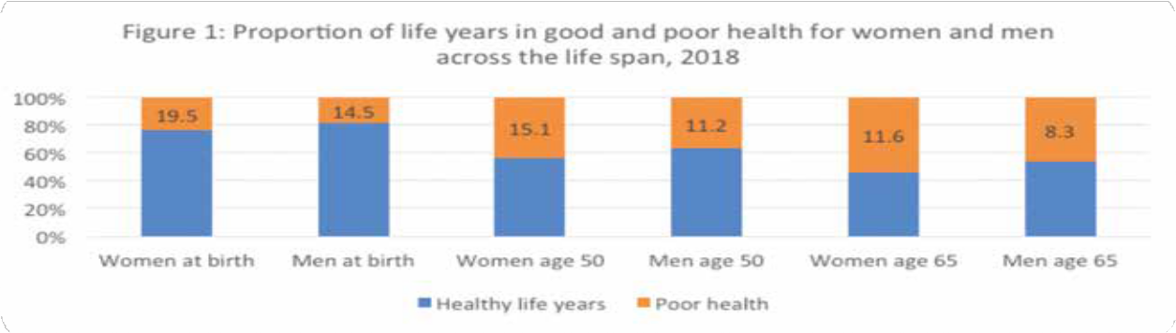

Significant differences also exist in life expectancy and healthy life years between EU member states. Figure 2 shows the situation for women aged 50. While EU average life expectancy for women is 34.9 years, this drops to 30.6 years in Bulgaria and rises to 37.2 years in Spain and France. These differences are even more stark for healthy life years, with an EU average of 19.8 years ranging from 11.9 years in Latvia to 27.1 years in Sweden.⁶

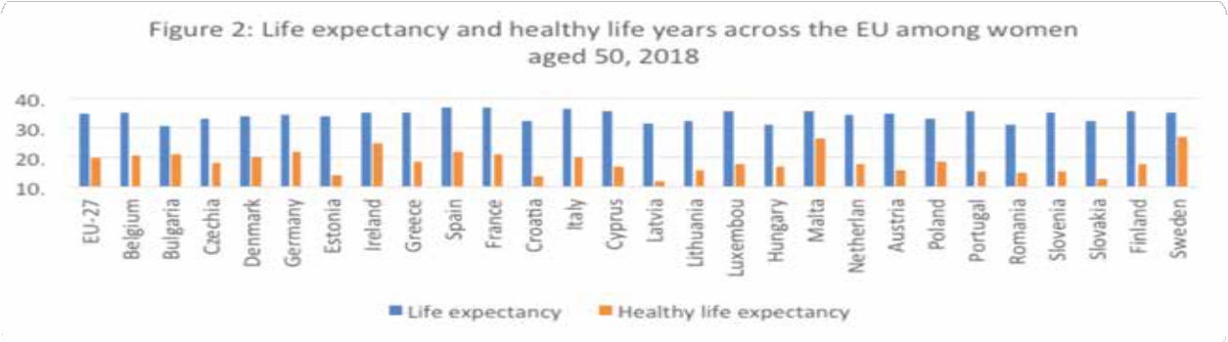

Causes of death in women aged 50 and older
Almost two-thirds (65.3%) of all deaths among women in the EU in 2016 occurred in those aged 80 and older. Women aged 65 to 79 accounted for a further quarter (23.3%) while 8.4% of deaths occurred in women aged 50-64 and 3% in those aged less than 50 years.⁷
The main causes of death in women aged 50 and older are shown in Figure 3. Cardiovascular diseases and cancers are the two main causes, accounting for 41% and 23% respectively of all deaths. While they remain the two main causes of death across all age groups over 50, the proportions vary significantly. Cardiovascular diseases are responsible for almost half (47%) of all deaths in women aged 80+, around one-third (32%) in women aged 65 to 79 and nearly one in five (19%) of deaths among women aged 50 to 64 years. Conversely, cancers account for more than half (52%) of deaths in women aged 50-64, 38% of deaths in those aged 65 to 79 and 14% of deaths among women aged 80 years and older.⁸
While more than half of deaths among women aged 50+ are due to either cardiovascular diseases or cancers in every EU member state, the proportions vary considerably, as illustrated in Figure 4. Cardiovascular diseases account for 73% of deaths in Bulgaria but only 27% in the Netherlands and France. Deaths due to cancers range from 14% in Bulgaria to 29% in Denmark and Ireland. Other causes (excluding cardiovascular diseases or cancers) are attributed to just 14% of deaths in Bulgaria compared to 49% in France.

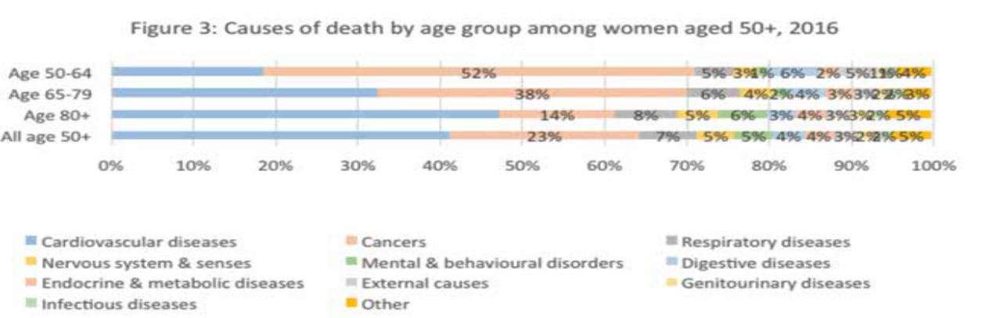

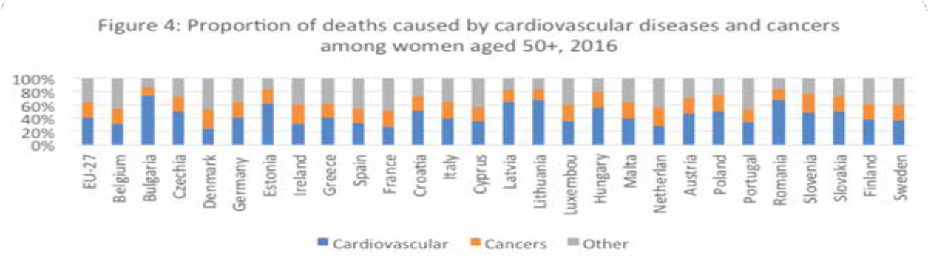

Preventable and treatable mortality among women
Figure 5 illustrates the death rates among women³ for the EU as a whole and within member states. As well as total mortality, it shows deaths that could have been avoided through public health or other preventative interventions (preventable mortality) or through effective and timely health care (treatable mortality). The total death rate ranged from 109 in Spain to 328 in Romania with an EU average of 168. There were also significant differences in preventable mortality between member states, from 50 in Cyprus to 190 in Hungary, while the rate of treatable mortality ranged from a rate of 56 in Spain to 161 in Romania.⁹

- The above figures include deaths among women of all ages, however deaths in women aged 50+ account for 97% of all
deaths

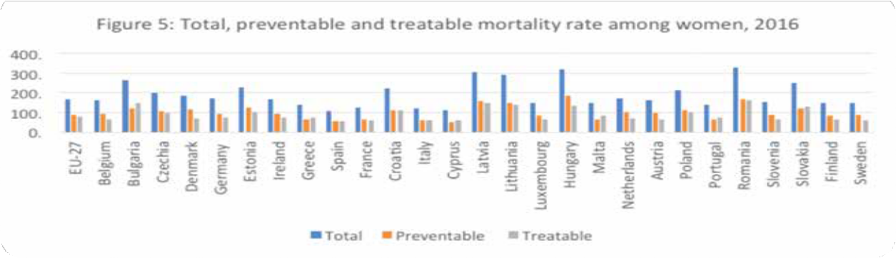

Chronic disease
Chronic disease is common among middle aged and older women and increases with age as shown in Figure 6. 41% of women aged 45 to 64 years in the EU report having one or more chronic diseases, rising to 61% among women aged 65 and older. Prevalence varies between member states with Italy reporting the lowest prevalence for both middle aged and older women (13% and 39% respectively) compared with 59% among middle aged women in Finland and 87% among older women in Cyprus.¹⁰

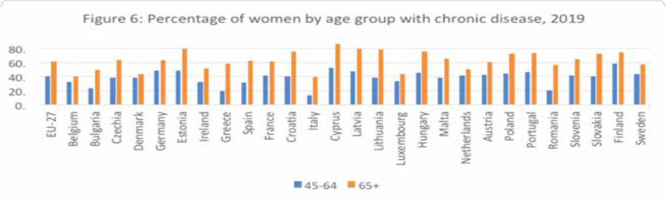

Factors affecting women’s health and well being in older years
Gender roles and norms, often established in childhood, and unequal access to power and resources between men and women, strongly impact on women’s health.¹¹ As women age, they experience multiple inequalities through the compounding effects of gender and age. Two important issues that are gaining increasing attention are inequalities in employment and financial resources and inequalities in access to and experience of healthcare. In the case of employment and caring responsibilities, health impacts may be indirect through limiting opportunities for financial independence or may occur as a direct consequence of working conditions.

Employment and financial resources
Despite welcome moves towards gender equality in the workplace and in work life balance, women continue to be disadvantaged. The European Commission’s Gender Equality Index for 2020 demonstrates this across several domains, three of which are shown in Figure 7. Women face challenges in labour market participation, time use and financial resources throughout their working years.¹²

Figure 7: Gender differences across indicators for work, money and time
 |  | Women | Men
Work | Full time equivalent employment rate | 42% | 57%
Work | Duration of working life | 34 years | 39 years
Work | Segregation in employment | 31% | 8%
Work | Flexibility | 23% | 27%
Work | Career Prospects Index | 63 points | 64 points
Money | Mean monthly earnings | €2,249 | €2,809
Money | Mean yearly household net income | €17,860 | €18,668
Money | At risk of poverty | 17% | 16%
Money | Income distribution | 20% | 19%
Time | Caring for others every day | 38% | 25%
Time | Cooking and/or housework every day | 79% | 34%

Participation in the labour market
Women have lower participation rates than men in the labour market across the EU. Among those aged 50 to 64 years, 60% of women are employed compared to 73% of men. In the majority of member states, more men than women of this age are employed, the exceptions being Estonia, Finland, Lithuania and Latvia. The gap is widest in Malta where 75% of men are employed compared with 44% of women and smallest in Latvia and Lithuania with a difference of only 0.2%.¹³
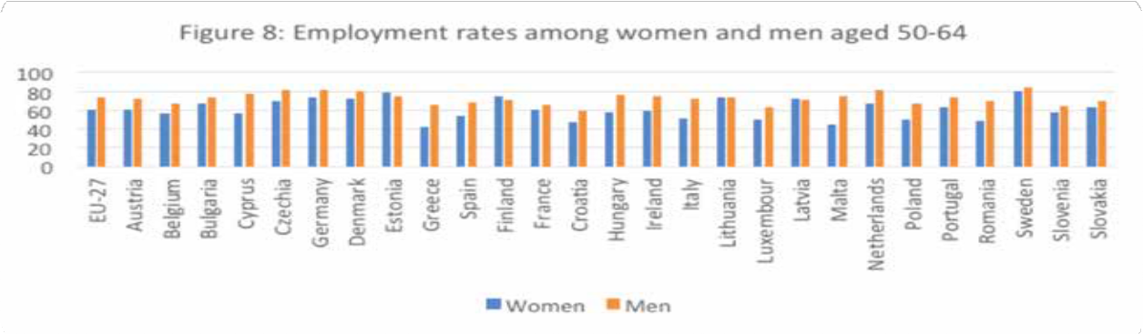

At EU level, the proportion of women to men working part-time is 3.6 but proportions vary between member states. As shown in Figure 9, Romania is the only country where less women than men work part-time (0.8) while in Germany, the proportion is 5.2.¹⁴
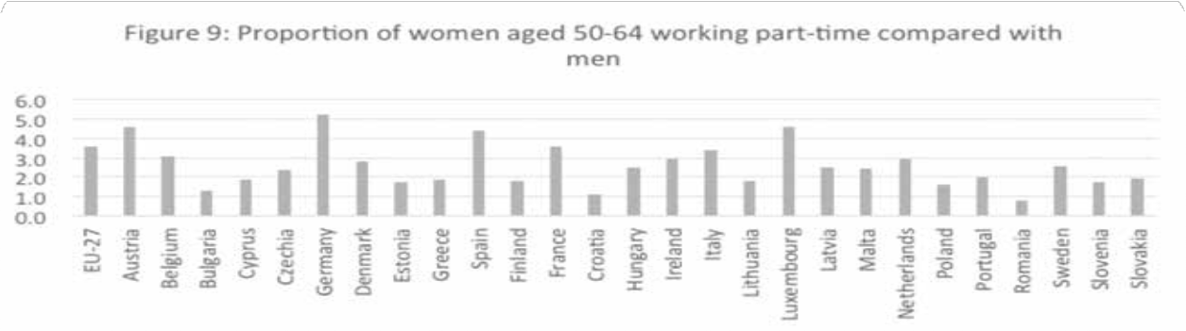

Women have shorter working lives than men as shown in Figure 10. A gap of 4.9 years exists at EU level, with women working an average of 33.4 years compared to 38.3 years for men. Lithuania is the only member state where women work marginally more years than men (0.80) years).

Across member states, the biggest gap is in Malta where women work 9.1 years less than men while in Latvia women and men both work an average of 36.8 years. The number of years worked by women also varies significantly between member states, from 27.3 years in Italy to 41 years in Sweden.¹⁵
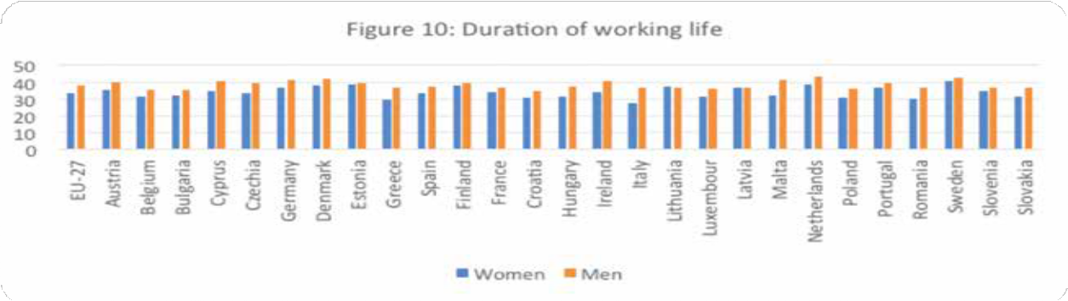

The uneven concentration of women and men in different sectors of the labour market is a persistent problem in the EU. 30% of women compared with 8% of men work in education, health and social work, which are traditionally low-paid sectors. The reverse is true for employment in science, technology which are higher-paid sectors.¹⁶ Women are also less likely to advance to higher positions than men.¹⁷

Informal/unpaid work
When paid and unpaid working hours are combined, women in the EU⁴ continue to work more hours than men: 55 hours per week compared to 49.¹⁸ Unpaid work includes housework tasks and care responsibilities. 94% of employed women are involved in at least one unpaid care work activity at least several times a week, compared with 70 % of employed men.¹⁹ Among unemployed and underemployed people of working age, the gender divide is even higher. 32% of economically inactive women aged 20 to 64 are not in paid work due to family and/or care responsibilities compared to 5% of inactive men in the same age group.²⁰

Women of pre retirement age (50-64 years) are most likely to care for older people and/ or people with disabilities. In the EU, 21 % of women and 11 % of men of this age provide long- term care every day or several days a week, compared to 13 % of women and 9 % of men aged 25-49 years.²¹ Differences also exist between member states in the percentage of older women providing regular care. About a third of women aged 50-64 years in Belgium (37 %), France (33%) and Latvia (33 %) provide care at least several days a week compared with less than 10% in Germany and Sweden.²²

- In this section (Informal/unpaid work), EU refers to EU-28 including the United Kingdom.
The intersection of gender and age underscores the particularly disadvantaged position of older women in the gender division of informal care responsibilities and the challenge that intensive care poses on their work-life balance. In addition to caring for older relatives, many women aged 50+ are also caring for their children and grandchildren. In 2019, 25.8% of births were to women aged 35 and older while more than one in 20 births were to women aged 40+.²³ Although people aged 50-64 years are still economically active in many member states, their employment rates are much lower, especially for women involved in informal care.²⁴ At EU level, 5.4% of women aged 50 to 69 years took early retirement for family or care-related reasons compared to 1.5% of men.²⁵

Earnings, life-time savings and pensions
In 2018, women’s gross hourly earnings were on average 14.1 % below those of men in the EU-27. The gender pay gap varies significantly across EU member states, ranging from less than 3% in Luxembourg and Romania to more than 20% in Austria, Czechia, Germany and Estonia. However, a lower gender pay gap in some countries may reflect a lower employment rate of women and not that women are better paid. A high gender pay gap may reflect a labour market in which women are more concentrated in low-paid sectors and/or one in which a significant proportion of women work part-time. However, patterns of paid and unpaid work during working years do not fully explain the gender pay gap. Women tend to earn less per hour than men for the same job across all sectors and occupations. ²⁶ Pension gaps are considerably larger than gender pay gaps due to a combination of women on average working fewer years in their career, fewer hours per week and receiving less income per hour. In 2017, women pensions were 35.7 % lower than those of men across the EU-28.²⁷ Unequal access for women to economic resources has health and social consequences. Women are more likely to be financially dependent on their partner and less likely to be able to afford healthcare services.²⁸

Sex and gender impacts on access to and experience of healthcare
Clinically significant differences exist between men and women in screening, risk factors, treatment and prognosis across a broad range of diseases. Diseases can manifest differently in men and women due to biological, psychological and/or social differences. Mechanisms underlying biological (sex) differences include genetics, epigenetics and hormones while social constructs of gender impact the way men and women use services and the responses they receive. ²⁹ ³⁰ Ignoring sex and gender differences in healthcare has the potential to compromise the accuracy of science, result in detrimental health outcomes, increase health costs, and have implications beyond health, including social services and aged care.³¹

Health systems and health care services
Health is one of six domains on which the EU’s Gender Equality Index is based and includes health status, health behaviours and access to healthcare. In 2020, the health score for the

15

EU⁵ was 88 but there were significant differences between member states, ranging from 70.2 in Romania to 94.5 in Sweden. Women are more likely to experience poorer health, less access to healthcare and lower levels of health enhancing physical activity than men.³² Women report higher unmet needs for healthcare than men. At EU level, 32% of women aged 45 to 64 years reported having unmet needs compared to 26% of men in the same age group. These gender differences persist across a range of reasons including waiting lists (length of time the person is waiting to receive a healthcare appointment), financial (having sufficient funds to pay for healthcare) and distance (how accessible healthcare is in terms of distance and transport).³³
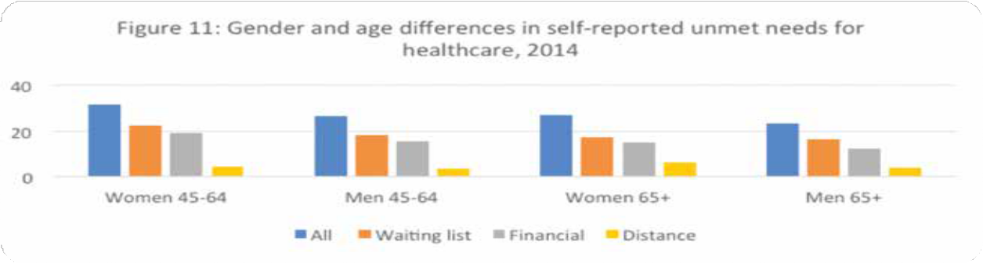

The percentage of those reporting unmet healthcare needs varies significantly between member states but gender differences persist. Among those aged 45 to 64, Portugal had the highest percentage of women reporting unmet needs (50%) and the biggest gender difference, with 39% of men reporting unmet needs. Within the same age group, women and men in the Netherlands reported the lowest percentage of unmet needs (7% for both).³⁴
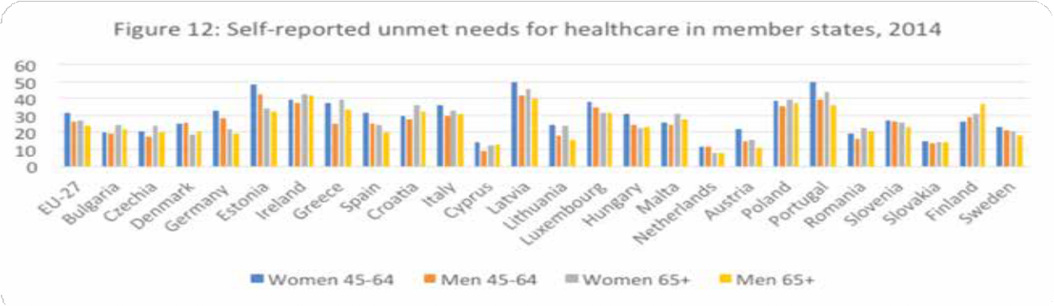

- The EU Gender Equality Index scores for 2020 include the United Kingdom.

16

At EU level, slightly more native women aged 45-64 reported unmet needs for medical examination than foreign born women (3.4% and 3.1% respectively). However, this trend was not reflected across member states, with 18 states reporting a higher level of unmet needs among foreign-born women. The biggest gap between these native and foreign-born women was in Denmark (9.1% and 27.3% respectively). One member state, Italy, reported no difference (3%).³⁵

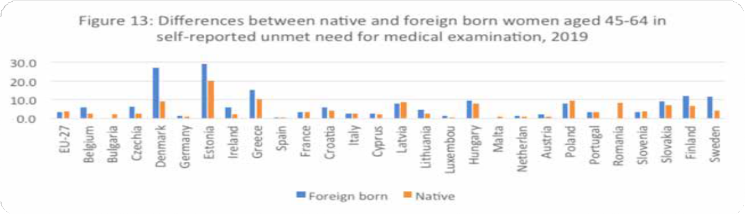

The impact of gender in the use of services is not limited to individuals’ health-seeking behaviour; gender biases also influence the provision of services. Women and men use healthcare in different ways. Women are more likely than men to present ‘invisible’ illnesses and disabilities which are often not adequately recognised by the healthcare system. Examples include depression, eating disorders, disabilities related to home accidents and sexual violence, as well as diseases and disabilities related to old age.³⁶ However the current model of healthcare delivery predominately employs a “one-size fits all” approach.³⁷
Overall, health professionals’ competence in understanding gendered healthcare-seeking patterns is weak. The selection, design and organisation of services do not consider gender norms, roles and power relations to respond to the health needs of women and men. Awareness of differences in physiological risk profiles and symptoms presented by women and men are not fully integrated into health services’ responses in many countries.³⁸

Health research
Historically across a broad range of health domains, data has been collected from men and generalised to women. Gender medicine is quite well established in cardiovascular, pulmonary and autoimmune diseases as well as in rheumatology and endocrinology. Significant gender- differences are also known in neurological and gastro enterological diseases and mental illness. The issue of medication, however, is severely under-researched: sex and gender disparity
in

enrolment in clinical trials continues to be a substantial challenge while proper sex or gender consideration to evaluate disparities in drug safety and efficacy is largely absent from clinical trials. There have been calls for greater consideration of sex and gender throughout the research process, from the design of research questions to the interpretation of study results, with segregation of results by sex or gender.³⁹ ⁴⁰

Priority issues

Priority issues
This section focuses on current status for middle aged and older women in selected areas, exploring the research on gender differences in prevalence, diagnosis, treatment and prognosis. Cardiovascular disease and cancer remain leading causes of mortality and morbidity for women, osteoporosis, dementia and urinary incontinence are more prevalent among women while vaccination and digitalisation are current/emerging issues with both ageing and gendered dimensions.

Cardiovascular disease
While cardiovascular mortality is declining overall, this decline has been smaller for women and, coupled with their greater longevity, this means that the burden of cardiovascular disease (CVD) is gradually shifting onto women particularly as they age. At age 40, men account for 75% of all CVD deaths, by age 75 this has reduced to around half and by age 95, 78% of deaths from CVD are in women.⁴¹
Women’s experience of CVD is different from men’s experience. A reduction in hormone levels as women enter menopause is linked with a web of risk factors for CVD including obesity, diabetes, hyperlipidaemia, hypertension and metabolic syndrome.⁴² Lifestyle factors, such as tobacco smoking, unhealthy diets, harmful use of alcohol, and physical inactivity are important predictors of CVD for both men and women.⁴³ However their impact on cardiovascular disease differs both due to gender differences such as women being less physically active than men and sex differences in how some risk factors such as smoking appear to carry a higher risk for women.⁴⁴ For women who smoke and use oral contraceptives, the risk is further increased.⁴⁵
As indicated in Figure 3, CVD is the main cause of death in women aged 50 and older with incidence increasing in older age: 95% of deaths occur in those 65 years and older.⁴⁶ Figure 14 shows deaths from CVD among women aged 65 and older across EU member states. At EU level the standardised death rate for this group was 1,517. This ranged from 749 in France to 4,420 in Bulgaria.⁴⁷
As well as differences in overall death rates from CVD between member states, there are also differences in the proportion of deaths from different types of cardiovascular disease as shown in Figure 15. At EU level, cause of cardiovascular death is fairly even spread across four main types: ischaemic heart disease, other heart disease, cerebrovascular disease and other circulatory disease. However, these range considerably at member state level.⁴⁸
Women report significant limitations in activity due to CVD. Figure 16 shows the percentage of women who reported severe limitations due to chronic consequences of heart attack, coronary heart disease and stroke. Significant differences exist between member states across all three aspects of CVD: 1.6% of women in Denmark reported severe limitations due to heart attack

compared with 10.4% in Poland. For coronary heart disease, there was an even bigger range, from 3.2% in Belgium to 37.4% in Poland while only 0.7% of women in the Netherlands reported chronic consequences of stroke compared with 20.4% of women in Bulgaria. Of the three cardiovascular diseases, most member states report the highest percentage of coronary heart disease, with the exception of Belgium and Cyprus which report higher percentages for both stroke and heart attack and Spain which reports a marginal higher percentage of stroke. ⁴⁹
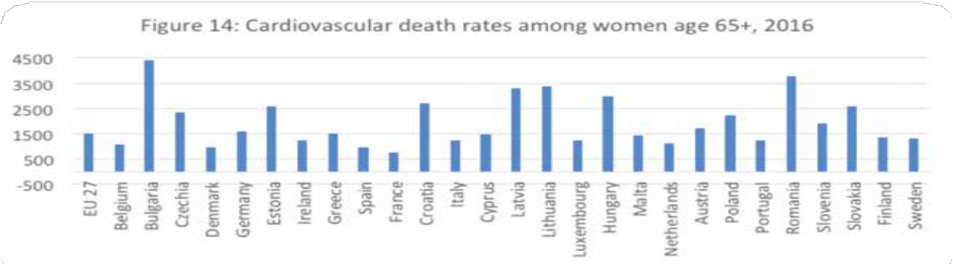
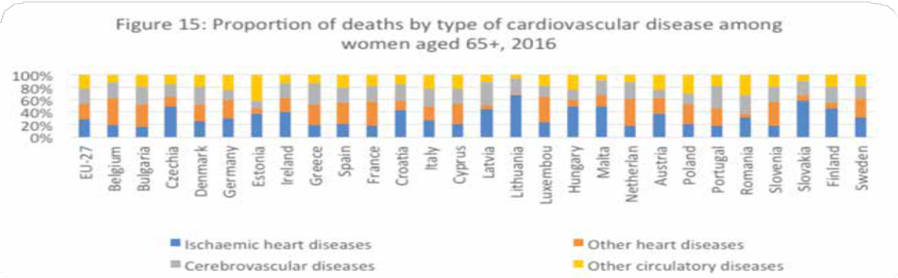
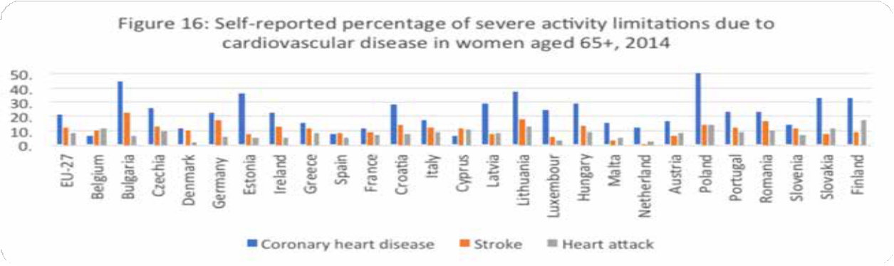

High blood pressure is a significant risk factor for CVD. Current recommendations indicate that those with existing hypertension should have their blood pressure monitored at least annually.⁵⁰ Figure 17 shows that at EU level 74% of women aged 45-64 and 88% of women aged 65 and older report having their blood pressure checked in the past 12 months. ⁵¹

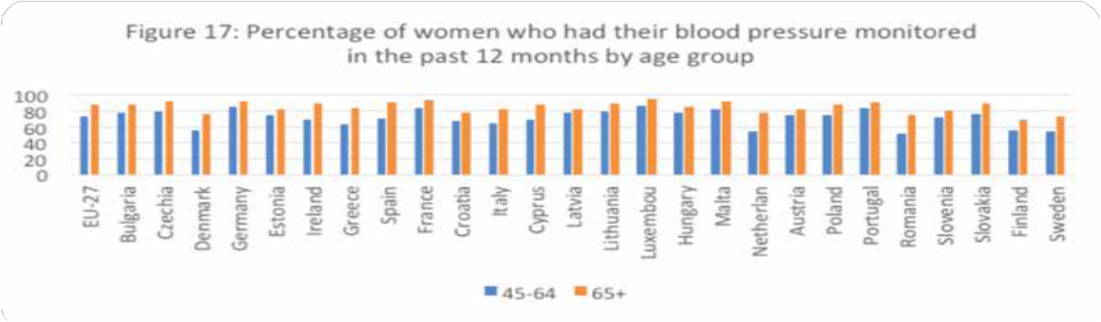

Cancer

As shown in Figure 3, cancer is the main cause of death among women aged 50-64 years accounting for 52% of all deaths in this age group, and the second highest cause of death in all women aged 50+ and older. However, more than three quarters of all cancer deaths in women occur in women aged 65 and older.⁵² While some cancers affect only women (such as cervical, uterine, ovarian) or mostly women (breast cancer), others affect men and women in different ways. For example, the incidence of lung cancer amongst women is increasing rapidly and is now also one of the most common cancers. Among the gynaecological cancers, risk of ovarian and uterine cancers increase with age with most cases being diagnosed after menopause.⁵³

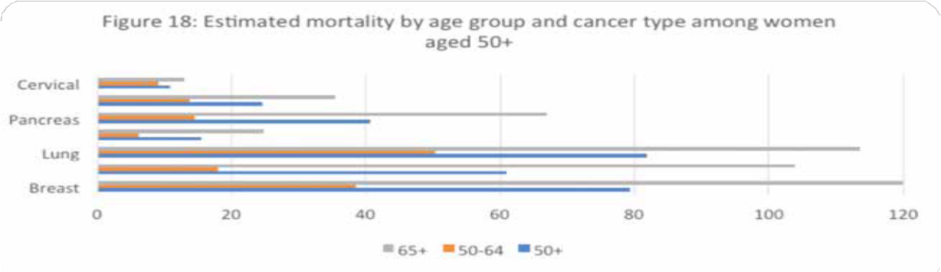

Estimates for 2020 among women aged 50 and older indicate a total of 530,493 deaths from all cancer types and 1,064,432 new cases. Breast cancer is estimated to be responsible for 16% of deaths, closely followed by lung (15.8%), with other significant cancers including colorectal (12.7%), pancreatic (8.3%) and ovarian (4.8%). Breast cancer is also estimated to be the most common diagnosis in 2020 (26.9%) followed by colorectal (13.4%), lung (10.2%), uterine (6.4%) and pancreatic (4.4%).⁵⁴ Figure 18 shows the estimated age standardised mortality rate by age group within those aged 50 and older. There are more deaths among those aged 65+ for all seven types of cancers but the proportions vary considerably across cancer types, with the difference being closest for cervical cancer and greatest for colorectal cancer.⁵⁵ The standardised death rate from all types of cancer among women aged 65 and older is 738 deaths per 100,000, as shown in Figure 19. This ranges considerably between member states, from 558 deaths in Bulgaria to 1013 in Denmark.⁵⁶
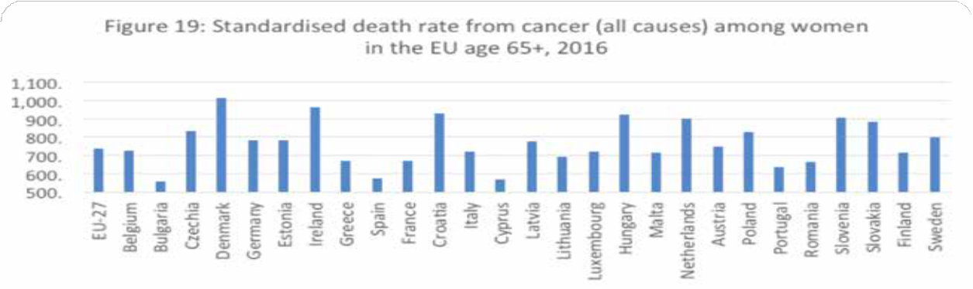
Figure 20 shows the three main causes of cancer mortality among women aged 65 and older at EU and member state levels. While at EU level, breast cancer has the highest standardised death rate, closely followed by lung then colorectal cancer, many member states show a different pattern, with lung cancer having a much higher mortality rate in several countries including Demark, Ireland, Hungary and the Netherlands. Colorectal cancer has the highest mortality rate in Estonia and Spain.⁵⁷
Breast and cervical cancer screening programmes are strongly associated with a reduction in cancer ^{mortality.}58 59 Most EU member states have developed population-based screening programmes for both breast and cervical cancers, but they differ in terms of organisational characteristics, implementation stage, and coverage. 60 Exceptions are Bulgaria and Greece which have neither, Slovak Republic (cervical only), Cyprus, Luxembourg, Austria and Spain (breast ^{only).}61 In some member states, opportunistic screening takes place. Figure 21 shows data from member states for which data was available in 2017, of the percentage of the relevant population included in screening ^{programmes.}
62

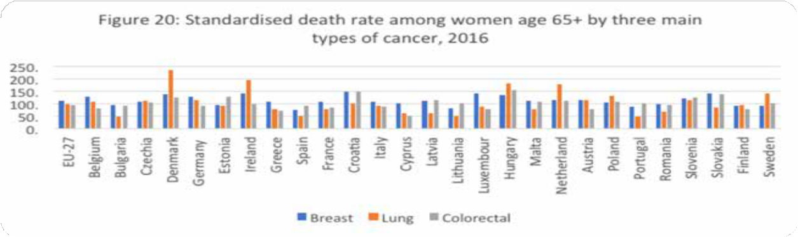
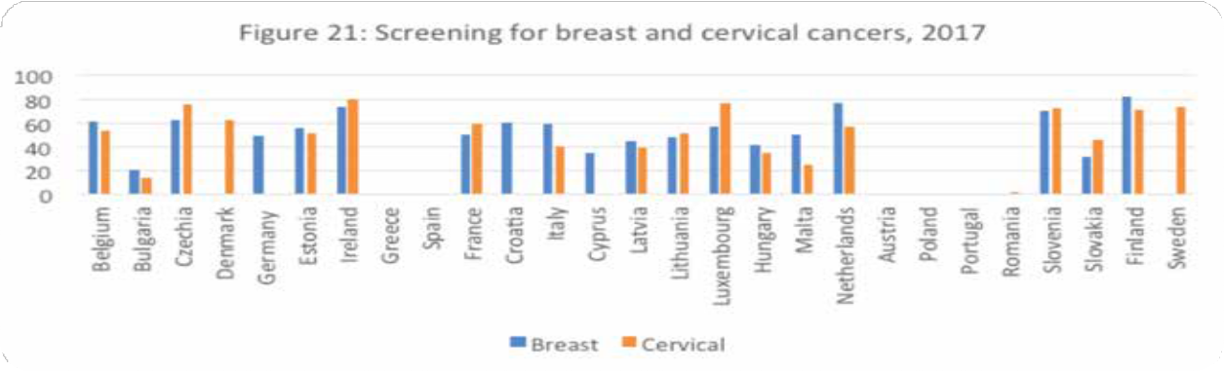

Since vaccination programmes to protect against human papilloma virus (HPV - the main cause of cervical cancer) target younger age groups, national cervical cancer screening programmes are the best strategy to tackle incidence and mortality from this largely preventable disease among midlife and older women.⁶³

Mental health and neurological disorders
Mental health and neurological disorders are the third highest cause of death in the EU⁶ when stroke (which accounts for 35% of deaths from neurological disorders) is included.⁶⁴ These include neurodegenerative disorders such as Parkinson’s disease, Alzheimer’s and other dementias and mental disorders including schizophrenia, depression, bipolar disorder, alcoholism, and drug abuse. As shown in Figure 3, deaths from neurological disorders, excluding those from stroke, cause 10% of all deaths in women aged 50 and older (5% from nervous system, 5% from mental and behavioural disorders). The percentage of deaths rises with increasing age from 4% in those aged 50 to 64 years up to 11% in women aged 80 and older.⁶⁵ Figure 22 shows large

- Includes the United Kingdom, as cited in the Global Burden of Disease Study 2017 (EU-28).

differences in deaths from mental and neurological disorders among older women across EU member states.⁶⁶
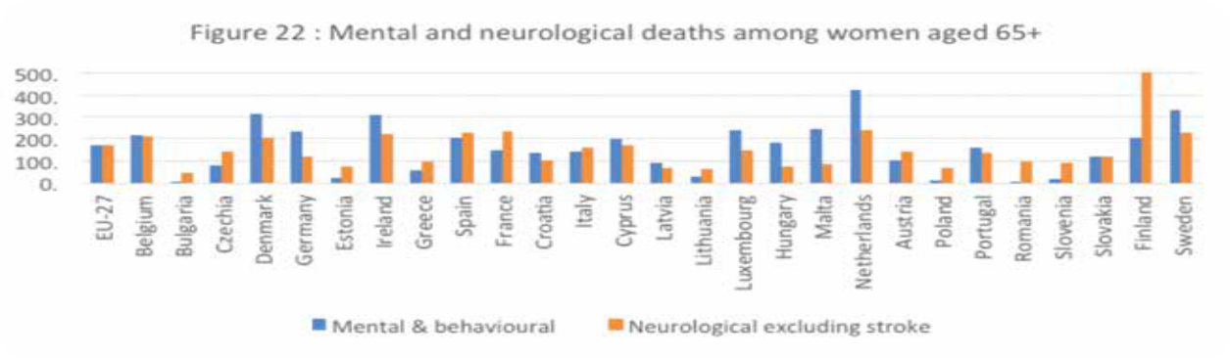

Dementia

Dementia has been recognised as the greatest global and societal challenge for health and social care in the 21st century. It is the only condition in the top 10 causes of death without a treatment to prevent, cure or slow its progression has a disproportionate impact on the capacity for independent living compared to any other chronic disease. The number of people living with dementia in the EU has been estimated at 7,853,705. Research suggests that prevalence rates may be much higher due to widespread under diagnosis. Women continue to be disproportionately affected by dementia with an estimated 4,928,436 women affected by dementia in 2018 compared to 2,464,902 men. Given current population projections, estimates for 2050 indicate these figures will rise to 9.4 million for women and 5.4 million for men.⁶⁷ Figure 23 shows cause of death due to Dementia and Alzheimer’s Disease among women aged 65 and older across member states.⁶⁸
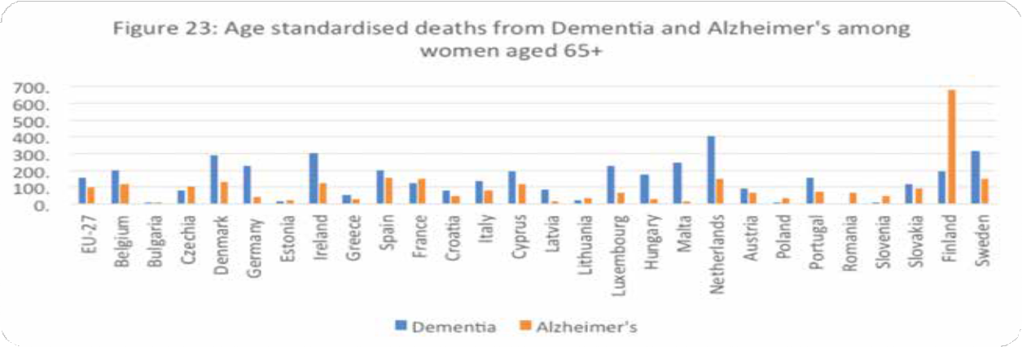

Depression

Depression is more prevalent in women than men in the EU and the gap widens with increasing age. Among those aged 50 to 64 years, 10.3% and 6.5% of women and men respectively report chronic depression, while for those aged 65 and older, almost twice as many women report chronic depression compared to men (11.4% and 5.8%).⁶⁹ In addition, depression is a risk factor for dementia⁷⁰, suicide⁷¹, and cardiac disease⁷². Differences in socioeconomic factors, including abuse, education and income, may impact the higher rate of depression in women while biological contributors may include variation in ovarian hormone levels and particularly decreases in oestrogen.⁷³ ⁷⁴ There are marked differences between member states both in the percentage of women reporting chronic depression and in the proportion of depression reported by age group as shown in Figure 24.⁷⁵

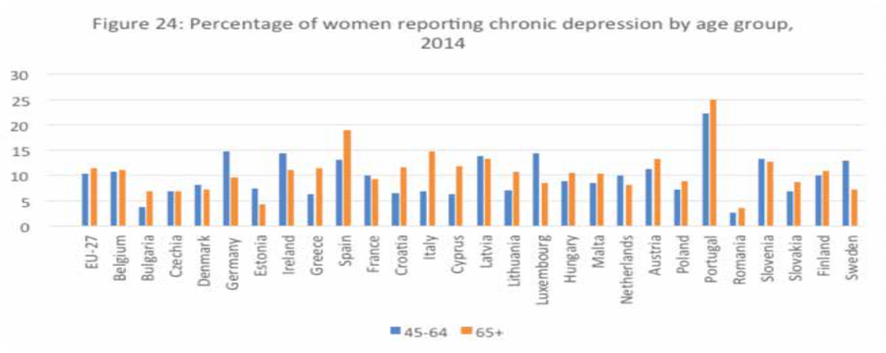

Parkinson’s Disease

There is growing evidence that Parkinson’s disease (PD) affects women and men differently. The risk of developing PD is twice as high in men than women, but women experience a more rapid disease progression and a lower survival rate.⁷⁶ Figure 25 shows significant differences between member states⁷ in the mortality rate from PD for women aged 65 and older.⁷⁷

Osteoporosis and bone health
Osteoporosis is a chronic condition whereby bones become less dense and lose their strength. This greatly increases the risk of painful and often disabling broken bones, known as fragility fractures. Osteoporosis is often called the silent disease because many people are not aware that they have it until they break a bone. Even then, around 80% of patients are still not diagnosed and treated for osteoporosis. Without appropriate treatment, people are at higher risk of further fractures, resulting in long-term disability and loss of independence.⁷⁸
Osteoporosis affects women at a much higher rate than men due to an accelerated bone loss among women in the first years after menopause. Across the EU, 22 million women and
5.5 million men were estimated to have osteoporosis in 2010 with 3.5 million new fragility fractures sustained. The economic cost of this across the EU was calculated at Ð37 billion with 26,300 life years lost and 1.16 million quality-adjusted life years lost on a yearly basis.⁷⁹ As life expectancy continues to rise, so will osteoporosis, particularly among older women, with its resulting fractures and associated social and economic costs.
Osteoporosis is often wrongly assumed to be a natural consequence of ageing, rather than a preventable disease. Changes in lifestyle, investing in prevention at an early age and making screening and treatment more widely available can help mid-life and older women to avoid fractures, stop bone loss and even strengthen bones to a certain degree.⁸⁰ But across Europe, almost 70% of women over 70 who have osteoporosis have not been diagnosed, and even after a fracture, 60–85% of women do not receive treatment to prevent subsequent fractures from occurring.⁸¹

Urinary incontinence
Urinary incontinence (UI) is more than twice as common in women as in men; Female physiology makes women more vulnerable to developing UI while pregnancy, childbirth and menopause increase both the short and long-term risk.⁸² Estimates indicate that 25-45% of women will develop UI during their lifetime.⁸³ Given increased life expectancy especially amongst women, it is likely to become even more prevalent in the future. In the EU, 5.7% of women aged 45 to 64 years report having UI, rising to 24.3% in those aged 75 and older.⁸⁴
Urinary incontinence has been described as a double burden for women
as not only are they more likely to develop the condition, they are also more
likely to provide care to people living with UI.85
There are an estimated 15 million informal carers in Europe caring for someone with UI.⁸⁶ Despite its prevalence and impacts, a lack of understanding, awareness and support surrounds the condition. Even when help is sought, people with incontinence and their carers can struggle to navigate their way through often fragmented and inconsistent support systems.⁸⁷ Incontinence can have a severe impact on the quality of life and wellbeing of the individual and is generally higher than for other chronic conditions.⁸⁸ It carries an enormous stigma, with many people suffering in silence due to shame and embarrassment, which may in turn lead to stress, fear, depression, decreased social and physical activity and social isolation.⁸⁹

- Standardised death rate in Finland is 678, almost four times higher than the next highest member state. It has been removed from Figure 25 for display purposes.

Digitalisation
Digitalisation is an umbrella term for the trend and impacts of the increasing use of digital technologies such as smart phones, global information networks and virtual reality. As societies become ever more dependent on digital technologies and infrastructure, concerns are increasingly being voiced about age and gender digital divides.⁹⁰ While information and communication technologies (ICTs) are recognised as having the potential to promote gender equality and women’s empowerment, women access and use ICTs less than men, which can exacerbate gender inequalities.⁹¹ Four areas in which gender inequalities impact the digital agenda include: gender gaps and differences in access to and use of digital technologies; gender gaps and differences in digital-related education: segregation across fields of study between women and men and girls and boys; gender and the digital labour market: women’s low participation in the digital labour market and in particular in high-quality jobs and top management positions; ICT, cybercrime and gender.⁹²
Digitalisation also plays a role in providing health care for example through telemedicine.⁹³

Having a high level of education improves digital literacy for both men and women, the gap widens with 74% of men with high education having above basic digital skills compared with 64% of women.⁹⁴ At the same time, digitalisation can lead to important advances for the autonomy and active participation of older people but it can also exacerbate inequalities and/ or exclude those who have limited or a lack of access to digital technology.⁹⁵ The digital divide between generations is significant and it increases with age. 20% of adults aged 75 and older uses the internet at least occasionally, in comparison with 98 % of 16 to 29 year olds. Among those who use the internet, those aged 75 and older are less likely (46%) to use it for services such as online banking and shopping compared to those aged 16 to 29 years (81%). Lack of access and lack of skills have been identified as the main barriers to older people using the internet.⁹⁶

28

The gender gap in use of digital technology increases with age. Among those aged 16 to 74 years, 76% of women and 78% of men use the internet daily: this drops to 52% and 58% respectively in women and men aged 55 to 74.⁹⁷

Vaccination
Vaccinations are one of the most effective ways to combat morbidity and mortality from infectious disease across all age groups. Herd or population immunity is the indirect protection from an infectious disease that occurs when a population develops immunity due to exposure. While this can be achieved through allowing a disease to spread through the population, this can cause unnecessary illness and death, particularly among more vulnerable sections of the population. Among older people, vaccine-preventable diseases have a particularly high burden as ageing is associated with an increase in the risk and severity of infectious diseases. This is due to a combination of the immune system slowing down and being less able to fight off infections in older age and a higher prevalence of chronic conditions making this cohort more vulnerable to complications of infectious disease. In addition, people with pre-existing chronic conditions are at higher risk of their condition worsening after developing infections such as influenza.⁹⁸
To date, the focus at EU and member state level has been on influenza with little evidence of action on other vaccines.⁸ Even with this focus, coverage rates are inadequate amongst older people. In 2018, only 41% of adults aged 65 and older in the EU were vaccinated against influenza.⁹⁹ Data from self-reported influenza vaccination uptake shows gender differences by age with a marginally higher uptake amongst women than men aged 45-64 (12.8%; 12.4%) followed by a reversed pattern thereafter. Among those aged 65-74 uptake was 33.9% and 36.1% for women and men respectively, increasing to 47.6% and 53% among those aged 75 and older.¹⁰⁰ The burden from seasonal influenza has two aspects. Firstly, there is the severe disease and deaths. Secondly, and of greater economic impact, are the large numbers of mild to moderate cases which result in time off work, losses to production and pressure and costs on the health and social care services.¹⁰¹
As well as influenza, vaccines are available in Europe for other infectious diseases affecting older populations including pneumococcal diseases, herpes zoster (shingles), diphtheria, tetanus and pertussis. Their effectiveness has been demonstrated in terms of reducing the rates of hospitalisation, disability, dependency and death.¹⁰²
Evidence suggests that being more physically active can help to improve vaccine efficacy through boosting vaccine specific antibody responses. Given that participation rates in regular physical activity are lower for women overall and decline further with age, older women may be particularly affected.¹⁰³

- With the exception of action on COVID-19, addressed in the next section.
Gender differences in vaccination are not as evident as in other priority areas included in this report, however since women are more likely to be informal carers, their workload and their exposure increases when those they care for contract infectious diseases.

Impact of COVID-19 pandemic on midlife and older women’s health
The first European case of COVID-19 was reported in France on 24 January 2020; by 25 March all EU member states and more than 150 countries worldwide had been affected. At the time of writing (April 2021), 30.4 million cases and over 684,000 deaths had been reported in the EU due to COVID-19.¹⁰⁴ As well as the immediate threat to life and health, there is growing evidence of the long-term physical and mental health impacts of both the infection itself and measures taken to contain the virus such as reducing social contacts, limiting movement and restricting services. In addition, access to non COVID related healthcare including preventative and primary services such as cancer screening and treatment for new and ongoing illness has been adversely affected as many national and regional healthcare systems struggle to cope with the increased workload.¹⁰⁵ The pandemic has also exacerbated existing inequalities between women and men in almost all areas of life including women’s participation in the labour market and in unpaid work.¹⁰⁶ Women across Europe have been on the frontline of the coronavirus pandemic. As well as being the main providers of informal care, they also comprise 76% of healthcare workers, which increases their exposure to the virus.¹⁰⁷
To date (April 2021), four vaccines have been authorised by the European Medicines Agency and vaccine roll-out is underway across all member states. Given the disproportionate impact of COVID19 on older people, vaccination programmes have prioritised these groups. Frontline workers have also been prioritised however this has largely focused on those in paid employment and not, for example, informal carers. As vaccines begin to be administered, there have been calls to collect age and sex disaggregated data on the different responses of men and women across age groups, including the different responses of women taking hormone replacement therapy after menopause.
Conclusions
There have been welcome changes in policy and practice regarding women’s health since the establishment of the European Institute of Women’s Health (EIWH) in 1996. The eradication of gender based inequalities is now a policy priority at EU level and much work has taken place regarding healthy ageing. However, current policy and practice concerning ways in which gender and sex differences between women and men influence health in older age remains inadequate.
This report shows the challenges that middle aged and older women face across the EU as well as differences that exist between member states in terms of life expectancy, healthy life expectancy and causes of mortality and portrays a greater rate of preventable and treatable mortality among women in some member states.
Factors that affect health and women were considered across two broad issues, employment and financial resources and access to and experience of healthcare. Whatever the reason, the outcome of women earning less throughout their lives means less income and less opportunity to save during working life and lower pensions in older age due to reduced entitlements. Furthermore, recent changes in employment and social strategies serve to benefit younger women due both to the target age group (e.g., maternity leave) and the ability to accrue benefits over time. Older women have already accumulated the disadvantages of inequitable work practices and/or absence from the labour force having spent much of their working-age years in less favourable conditions. With regard to healthcare, biological and gender issues compound to women’s disadvantage in many areas of healthcare including research.
Finally, several existing and emerging issues affecting quality of life and life expectancy were explored in more detail to draw attention to these concerns. These include both long- term illnesses such as cardiovascular disease as well as broader issues such as digitalisation. Regarding illnesses, a common theme is the potential and often unrecognised impact of hormonal changes associated with menopause on a broad range of chronic diseases.

A snapshot of recent policy developments
Significant gains have been made in gender equality and age-friendly policies and practices at EU level and within member states. A recently published report by the European Commission’s DG Justice and Consumers ‘Gender equality and health’, provides a cross-cutting view of key health topics in the EU from a gender perspective and refers to many of the issues raised in this report.
In March 2020, the European Commission adopted a Gender Equality Strategy 2020-2025 which aims to achieve a gender equal Europe by tackling structural inequalities between men and women, sex discrimination and gender-based violence. In its first annual report, recent policy achievements are noted including the pay transparency measures proposed to ensure equal pay for equal work (further explored below), the adoption of an action plan to implement the European Pillar of Social Rights which includes targets for women’s participation in the labour market, and the 2020 Digital Education Action Plan and the European Skills Agenda which include a range of actions to increase women’s digital knowledge and skills. However, the report also acknowledges the detrimental impact of the COVID-19 pandemic on many aspects of gender inequalities (as described in a previous section ‘Impact of COVID-19’).¹⁰⁸

In February 2021, the European Commission presented Europe’s Beating Cancer Plan to support member states in strengthening policy and programmes at every stage of the disease: prevention, diagnosis, treatment, life as a cancer survivor and palliative care. Of particular note for midlife and older women’s health is the focus on screening services and on reducing cancer inequalities across the EU.
In addition, the adoption of the action plan to implement the European Social Pillar, in March 2021, includes actions to improve access to all across employment, pensions and long-term care.
Horizon Europe, is the new European Commission Framework Programme . It will run from 2021-2027, with a total budget of Ð95.5 billion. EU4Health, 2021–2027, is a vision for a healthier Europe, in practice it is a response to Covid-19. It focuses on health systems’ resilience. The areas of action are to improve and foster health in the EU; to protect people in the EU from serious cross-border threats to health; to improve medical products, devices, and crisis-relevant products, to strengthen health systems.

Steps for action
A comprehensive and supportive approach, including physical and mental health, must be taken to empower and support women to actively and healthily age.
Policymakers, practitioners, nongovernmental organisations and civil society can continue to improve the health and wellbeing of ageing women by simultaneously applying both a gender and an ageing lens in their research, policies, programmes and practices. The following steps build on previous recommendations made by EIWH and others to help overcome challenges faced by women in Europe as they age.
- Gender-blind healthcare can reinforce gender stereotypes and institutional biases, perpetuating discriminatory values, norms, and practices. Instead, the design and management of health services should consider gender norms, roles, power relations and cultures to respond to the health needs of women and provide gender-responsive care across health promotion, protection, prevention, diagnosis and treatment. EIWH supports a life course approach to women’s health that acknowledges the contribution of earlier life stages including the reproductive years to health in later life. Removing gender stereotypes extends to recognising women’s health and maternal health are not interchangeable and moving beyond the limitations of a reproduction-focused approach to women’s health, enabling the healthcare needs of older women to be properly addressed by healthcare professionals.
- While some aspects of the European Council’s conclusions on the ‘Economy of Well Being’ have been developed, one notable exception is in mental health. Since the WHO European Mental Health Action Plan concluded in 2020, this leaves a significant gap in the strategic development of mental health policy at EU level.
- The new clinical trials regulation (Regulation EU No 536/2014) is a major step forward in increasing clinical trial data transparency. Key issues going forward include addressing the under representation of women in clinical trials, including women aged 65 and older, and enforcement of the regulation when fully implemented.¹⁰⁹
- The Pharmaceutical Strategy for Europe, published in November 2020, addresses several issues highlighted in this report including access to healthcare, health research and digitalisation. The Covid-19 pandemic has disproportionately impacted women increasing inequalities in health. The EU4 Health programme should consider specific support for programmes and polices addressing the impact of covid on women’s health.
- There is a need for a European Mental Health Strategy led and coordinated by the European Union to ensure equitable access to prevention treatment and care, taking into account the cross-sectoral impacts of different policies on mental health. By developing a European strategy for mental health and wellbeing, the EU can improve the lives of millions of Europeans - both those affected by mental ill health, their families and friends - and contribute to inclusive and cohesive societies, a stronger economy, and development that is both sustainable and equitable.
- Horizon Europe should promote the availability of high quality, timely data disaggregated by age groups and sex allowing for greater visibility of issues. Existing gaps at the EU level and within member states should be addressed. There is a need to better understand how a range of determinants including sex and gender, disability, education, employment, ethnicity and age intersect.
- Policies that enable older women to maintain quality of life and remain independent extend beyond health and healthcare to include economic and social issues. The gender pay gap and the pension gap must be addressed. This includes adoption of the proposal for a directive on adequate minimum wages in the EU, published by the European Commission in October 2020. Action on minimum wages indirectly supports the reduction of the gender and pension gap given that many minimum wage earners are women.
- Women’s unpaid contributions to care and household duties must also be adequately recognised, valued and compensated. The adoption of the European Commission Work-Life balance directive in July 2019 is a welcome step in improving access to family leave and flexible work arrangements. However, it has been acknowledged that this alone will not close the gender care gap and EIWH supports calls to step up further efforts to reduce this gap.

Appendix: Recommendations from ‘Women in Europe’ report, 1996
EIWH urges the EU, together with Member States, to:

- Set time-based, achievable targets for reducing the incidence and severity of coronary heart disease, cancer, osteoporosis and depression in each Member State; Develop health policies at the European and Member State levels to address the underlying causes; Promote health policies throughout Europe that enable older women to maintain quality of life and remain independent; Design more effective education and health promotion programmes that motivate and enable women to live a healthier lifestyle; Educate health care professionals to give women the same level of care and attention that they give to men.
- EIWH calls on all health authorities and policymakers at local, national and European levels; nongovernmental and intergovernmental organisations; women’s and older persons’ groups; health care professionals; research groups, and the media to take action in these critical areas.

Health policy
- Adopt a new, coordinated effort to ensure the prolonged health, well being and independence of mid-life and older women.
- Set time-based, achievable targets for the reduction of coronary heart disease, cancer, osteoporosis and depression, thereby lessening the burden of disabilities and disease, not only on the sufferers but on society, their families and carers.
- Initiate further reports on the specific health problems of mid-life and older men and women.
- Exchange information and coordinate research data to provide a basis for informed decision making in order to raise standards throughout Europe.
- Develop standards and guidelines and spread the knowledge of best practices wherever possible to ensure more cost-effective, higher quality health care for women, especially for the disadvantaged.

Prevention and health promotion

- Focus health promotion policies on prevention to help conserve diminishing resources for diagnosis and treatment of disease.
- Discourage smoking among women of all ages, since smoking is the single greatest risk factor for many diseases.
- Screen for diseases best diagnosed early, following guidelines set by the European Commission to ensure the highest quality and the broadest coverage.

Education

- Educate women in the prevention, early detection and early treatment of the diseases and conditions that afflict them.
- Exchange information and coordinate research data to provide a basis for informed decision-making in order to raise standards throughout the EU.
- Develop standards and guidelines and spread the knowledge of best practices wherever possible to ensure more cost-effective, higher quality health care for women, especially for the disadvantaged.
- Strongly encourage European women to take part in research aimed at understanding, alleviating and solving their specific health problems.

Working together, the European Union and Member States, governments and non governmental groups, men and women, we can help to ensure that women in the EU have a greater opportunity to live their later years in good health and independence, with less burden imposed by disability and disease.

References
- Eurostat database: Life expectancy by age and sex in 2018 [DEMO_MLEXPEC] https://ec.europa. eu/eurostat Accessed 06/02/2021.
- Eurostat database: Population on 1st January 2020 by age, sex and type of projection [PROJ_19NP] https://ec.europa.eu/eurostat Accessed 06/02/2021.
- Eurostat database: Population on 1st January 2050 by age, sex and type of projection [PROJ_19NP] https://ec.europa.eu/eurostat Accessed 06/02/2021.
- Eurostat database: Healthy life years by sex, 2018 [HLTH_HLYE].
https://ec.europa.eu/eurostat Accessed 06/02/2021.
- Eurostat database: Healthy life years by sex, 2018 [HLTH_HLYE].
https://ec.europa.eu/eurostat Accessed 06/02/2021.
- Eurostat database: Healthy life years by sex [HLTH_HLYE].
https://ec.europa.eu/eurostat Accessed 06/02/2021.
- Eurostat database: Causes of death - deaths by country of residence and occurrence [HLTH_CD_ ARO].
https://ec.europa.eu/eurostat Accessed 06/02/2021.
- Eurostat database: Causes of death - deaths by country of residence and occurrence [HLTH_CD_ ARO].
https://ec.europa.eu/eurostat Accessed 06/02/2021.
- Eurostat database: Treatable and preventable mortality of residents by cause and sex [HLTH_CD_ APR]. https://ec.europa.eu/eurostat Accessed 06/02/2021.
- Eurostat database: People having a long-standing illness or health problem, by sex, age and labour status [HLTH_SILC_04].
https://ec.europa.eu/eurostat Accessed 06/02/2021.
- World Health Organization. Gender and health.
https://www.who.int/health-topics/gender Accessed 10/09/2021.
- European Institute for Gender Equality. Gender Equality Index 2020, Key findings for the EU. https://eige.europa.eu/ Accessed 20/02/2021.
- European Institute for Gender Equality. Gender Statistics Database: Work and labour market. EU Labour Force Survey data, 2017.
https://eige.europa.eu/ Accessed 20/02/2021.
- European Institute for Gender Equality. Gender Statistics Database: Work and labour market. EU Labour Force Survey data, 2017.
https://eige.europa.eu/ Accessed 20/02/2021.
- European Institute for Gender Equality. Gender Statistics Database: Work and labour market. Eurofound European Working Conditions Survey data, 2015. https://eige.europa.eu/ Accessed 20/02/2021.
- European Institute for Gender Equality. Gender Statistics Database: Work and labour market. EU Labour Force Survey data, 2017. https://eige.europa.eu/ Accessed 20/02/2021.
- European Institute for Gender Equality. Gender Statistics Database: Work and labour market. Eurofound European Working Conditions Survey data, 2015. https://eige.europa.eu/ Accessed 20/02/2021.
- Eurofound. Sixth European Working Conditions Survey, 2017 update. Eurofound, 2017.

- European Institute for Gender Equality. Gender inequalities in care and consequences for the labour market, 2020. Original data source European Working Conditions Survey, 2015.

- European Institute for Gender Equality. Gender Equality Index 2019, Thematic focus: Work life balance. Original data source Labour Force Survey data, 2018.
- European Institute for Gender Equality. Gender Equality Index 2019, Thematic focus: Work life balance. Original data source European Quality of Life Survey data, 2016.
- European Institute for Gender Equality. Gender Equality Index 2019, Thematic focus: Work life balance. Original data source European Quality of Life Survey data, 2016.
- Eurostat database. Live births by mother’s age and birth order [DEMO_FORDAGEC].
https://ec.europa.eu/eurostat Accessed 30/04/2021.
- European Institute for Gender Equality. Gender Equality Index 2019, Thematic focus: Work life balance.
- European Institute for Gender Equality. Gender Statistics Database: Work and labour market. EU Labour Force Survey data, 2012.
https://eige.europa.eu/ Accessed 20/02/2021.
- European Commission, DG Justice and Consumers. Factsheet: Equal pay? Time to close the gap, 2020.
- European Parliament. Briefing: The gender gap in pensions in the EU, 2019.

- Eurostat database. Self-reported unmet needs for specific health care-related services due to financial reasons by sex, age and level of activity limitation [HLTH_EHIS_UN2D]. https://ec.europa. eu/eurostat Accessed 20/02/2021.
- Mauvais-Jarvis, F., Merz, N.B., Barnes, P.J., et al. Sex and gender: modifiers of health, disease, and medicine. Lancet, Vol. 396, 2020.
- World Health Organisation. High level conference on non-communicable diseases. Why using a gender approach can accelerate non-communicable disease prevention and control in the WHO European Region, 2019.
- Wainer, Z., Carcel, C., et al. Sex and gender in health research: updating policy to reflect evidence. Medical Journal of Australia, Vol. 212, 2020.
- European Institute for Gender Equality. Gender Equality Index. Comparing health scores for the 2020 edition.
https://eige.europa.eu/gender-equality-index/. Accessed 20/02/2021.
- Eurostat database. Self-reported unmet needs for health care by sex, age, specific reasons and educational attainment level [HLTH_EHIS_UN1E]. https://ec.europa.eu/eurostat Accessed 20/02/2021.
- Eurostat database. Self-reported unmet needs for health care by sex, age, specific reasons and educational attainment level [HLTH_EHIS_UN1E].
https://ec.europa.eu/eurostat Accessed 20/02/2021.
- Eurostat database. Self-reported unmet needs for medical examination by sex, age, main reason declared and groups of country of birth [HLTH_SILC_29]. https://ec.europa.eu/eurostat Accessed 20/02/2021.
- European Institute for Gender Equality.
https://eige.europa.eu/gender-mainstreaming/policy-areas/ health
Accessed 20/02/2021.
- European Institute of Women’s Health. 21st anniversary expert conference. Right from the start: resetting the agenda in women’s health in Europe, 2018.
- World Health Organisation. High level conference on non-communicable diseases. Why using a gender approach can accelerate non-communicable disease prevention and control in the WHO European Region, 2019.
- Mauvais-Jarvis, F., Merz, N.B., Barnes, P.J., et al. Sex and gender: modifiers of health, disease, and medicine. Lancet, Vol. 396, 2020.
- Heidari, S., Babor, T.F., De Castro, P., et al. Sex and Gender Equity in Research: rationale for the SAGER guidelines and recommended use. Research Integrity and Peer Review. Vol 1(1), 2016.
- Eurostat database. Causes of death – deaths by country of residence and occurrence [HLTH_CD_ ARO].
https://ec.europa.eu/eurostat Accessed 15/12/20.
- European Heart Network. European Heart Health Strategy. Red alert on women’s hearts: women and cardiovascular research in Europe, 2009.
- European Society of Cardiology (2020). Fighting cardiovascular disease – a blueprint for EU action.

- Prescott, E., Hippe, M., Schnohr, P., et al. Smoking and risk of myocardial infarction in women and men: longitudinal population study. British Medical Journal, Vol. 316, 1998.
- Pomp, E.R., Rosendaal, F.R., Doggen, C.J. Smoking increases the risk of venous thrombosis and acts synergistically with oral contraceptive use. American Journal of Hematology, Vol. 83, 2008.
- Eurostat database. Causes of death – deaths by country of residence and occurrence [HLTH_CD_ ARO].
https://ec.europa.eu/eurostat Accessed 03/01/21.
- Eurostat database. Causes of death – standardised death rate by NUTS 2 region of residence [HLTH_CD_ASDR2].
https://ec.europa.eu/eurostat Accessed 03/01/21.
- Eurostat database. Causes of death – standardised death rate by NUTS 2 region of residence [HLTH_CD_ASDR2].
https://ec.europa.eu/eurostat Accessed 03/01/21.
- Eurostat database. Persons reporting a chronic disease, by disease, sex, age and level of activity limitation [HLTH_EHIS_CD1D].
https://ec.europa.eu/eurostat Accessed 03/01/21.
- European Society of Cardiology. 2018 ESC/ESH Clinical Practice Guidelines for the Management of Arterial Hypertension, 2018.
- Eurostat database. Self-reported screening of cardiovascular diseases and diabetes risks by sex, age and educational attainment level [HLTH_EHIS_PA2E].
https://ec.europa.eu/eurostat Accessed 28/02/21.
- Eurostat database. Causes of death – standardised death rate by NUTS 2 region of residence [HLTH_CD_ASDR2].
https://ec.europa.eu/eurostat Accessed 03/01/21.
- American Cancer Society. Cancer facts for women.
https://www.cancer.org/ Accessed 13/02/2021.

- European Cancer Information System. Estimates of cancer incidence and mortality in 2020, all cancer sites.

https://ecis.jrc.ec.europa.eu/ Accessed 28/02/2021.
- European Cancer Information System. Estimates of cancer incidence and mortality in 2020, all cancer sites.
https://ecis.jrc.ec.europa.eu/ Accessed 28/02/2021.
- Eurostat database. Causes of death – standardised death rate by NUTS 2 region of residence [HLTH_CD_ASDR2].
https://ec.europa.eu/eurostat Accessed 03/01/21.
- Eurostat database. Causes of death – standardised death rate by NUTS 2 region of residence [HLTH_CD_ASDR2].
https://ec.europa.eu/eurostat Accessed 03/01/21.
- Zielonke, N., Gini, A., Jansen, E., et al. Evidence for reducing cancer-specific mortality due to screening for breast cancer in Europe: A systematic review, European Journal of Cancer, Vol. 127, 2020.
- Jansen, E., Zielonke, N., Gini, A., et al. Effect of organised cervical cancer screening on cervical cancer mortality in Europe: a systematic review, European Journal of Cancer, Vol. 127, 2020.
- Gianino, M.M., Lenzi, J., Bonaudo, M. et al. Organized screening programmes for breast and cervical cancer in 17 EU countries: trajectories of attendance rates. BMC Public Health, Vol. 18, 2018.
- Ponti, A., Anttila. A., Ronco, G., et al. Cancer screening in the European Union - report on the implementation of the council recommendation on cancer. Screening, 2017.
- Eurostat database: Breast cancer and cervical cancer screenings [HLTH_PS_SCRE].
https:// ec.europa.eu/eurostat Accessed 28/02/2021.
- European Institute of Women’s Health. Women and cervical cancer in the EU, Policy Brief, 2017.

- Deuschl, G., Beghi, E., Fazekas, F., et al. The burden of neurological diseases in Europe: an analysis for the Global Burden of Disease Study 2017. The Lancet Public Health, Vol. 5, 2020.
- Eurostat database: Causes of death - deaths by country of residence and occurrence [HLTH_CD_ ARO].
https://ec.europa.eu/eurostat Accessed 06/02/2021.
- Eurostat database. Causes of death – standardised death rate by NUTS 2 region of residence [HLTH_CD_ASDR2].
https://ec.europa.eu/eurostat Accessed 03/01/21.
- Alzheimer Europe. Dementia in Europe, Yearbook 2019. Estimating the prevalence of dementia in Europe. UK data removed from cited EU level.
- Eurostat database. Causes of death - standardised death rate by NUTS 2 region of residence [HLTH_CD_ASDR2].
https://ec.europa.eu/eurostat Accessed 27/02/21.
- Eurostat database. Persons reporting a chronic disease, by disease, sex, age and educational attainment level [HLTH_EHIS_CD1E].
https://ec.europa.eu/eurostat Accessed 27/02/21.
- Rapp, M., Schnaider-Beeri, M., Wysocki, M. et al. Cognitive decline in patients with dementia as a function of depression. American Journal of Geriatric Psychiatry. Vol. 19(4), 2011.
- Bazin, N. Suicide and depression in the elderly. Psychol Neuropsychiatr Vieil. Sep (2), Suppl 1, 2004.

- Penninx, B., Beekman, A., Honig, A. et al. Depression and cardiac mortality: results from a community based longitudinal study. Arch Gen Psychiatry. Mar, 58(3), 2001.
- Albert P.R., Why is depression more prevalent in women? Journal of Psychiatry and Neuroscience, Vol. 40, 2015.
- Rai, D., Zitko, P., Jones, K., et al. Country- and individual-level socioeconomic determinants of depression: multilevel cross-national comparison. British Journal of Psychiatry, Issue 202, 2013.
- Eurostat database. Persons reporting a chronic disease, by disease, sex, age and educational attainment level [HLTH_EHIS_CD1E].
https://ec.europa.eu/eurostat Accessed 18/01/21.
- Cerri, S., Mus, L., Blandini, F. Parkinson’s Disease in Women and Men: What’s the Difference? Journal of Parkinson›s Disease, Vol. 9, 2019.
- Eurostat database. Causes of death - standardised death rate by NUTS 2 region of residence [HLTH_CD_ASDR2].
https://ec.europa.eu/eurostat Accessed 27/02/21.
- International Osteoporosis Foundation. What is osteoporosis?
https://www.osteoporosis. foundation/ Accessed 13/02/2021.
- Hernlund, E., Svedbom, A., Ivergard, M., et al. Osteoporosis in the European Union: medical management, epidemiology and economic burden. Archives of Osteoporosis, Vol. 136, 2013
- Borgstrom, F., Karlsson, L., Ortsater, G., et al. Fragility fractures in Europe: burden, management and opportunities. Archives of Osteoporosis, 2020.
- Foote, N. Broken bones, shattered lives: call for action as EU faces rise in osteoporosis. Preventing osteoporosis in the EU, Event report. EurActiv, 2020.
- Irwin, D.E., Milsom, I., Hunskaar, S., et al. Population-based survey of urinary incontinence, overactive bladder, and other lower urinary tract symptoms in five countries: results of the EPIC study. European Urology, Vol. 6, 2006.
- Milsom, I. Epidemiology of urinary incontinence and other lower urinary tract symptoms, pelvic organ prolapse, and anal incontinence. In: Incontinence 6th Edition 2017. Eds: Abrams, P., Cardozo, L., Wagg, A. et al. 6th International Consultation on Incontinence, Tokyo, 2016.
- Eurostat database. Persons reporting a chronic disease, by disease, sex, age and educational attainment level [HLTH_EHIS_CD1E].
https://ec.europa.eu/eurostat Accessed 18/01/21.
- Services for Supporting Family Carers of Elderly People in Europe: Characteristics, Coverage and Usage. Eurofamcare, 2006.
- Eurocarers. Joint position statement: Incontinence and the provision of better incontinence care at home and in the community. Patient and civil society representatives roundtable, 2015.
- European Institute of Women’s Health. Policy brief: Women and incontinence in the EU, 2018.

- Eurocarers. Joint position statement: Incontinence and the provision of better incontinence care at home and in the community. Patient and civil society representatives roundtable, 2015.
- Minassian, V.A., Devore, E., Hagan, K., et al. Severity of urinary incontinence and effect on quality of life in women by incontinence type. Obstetrics & Gynecology, Vol. 5, 2013.
- Dufva, V., Dufva, M. Grasping the future of the digital society. Futures, Vol. 107, 2019.

- Schonard, M. The underlying causes of the digital gender gap and possible solutions for enhanced digital inclusion of women and girls. Research paper prepared for the European Parliament, 2018.
- European Institute for Gender Equality. Gender and digital agenda, 2016.

- Goldstein, K. M., Zullig, L. L., Dedert, E. A., et al. Telehealth Interventions Designed for Women: an Evidence Map. Journal of general internal medicine, Vol 33(12), 2018.
- European Institute for Gender Equality. Gender Equality Index 2020, Thematic focus: Digitalisation in the world of work.
- Council of the European Union. Human rights, participation and well-being of older persons in the era of digitalisation. Council conclusions, 2020.
- European Union Agency for Fundamental Rights. What do Fundamental Rights Mean for People in the EU. Luxembourg, 2020.
- Eurostat database. Individuals - frequency of internet use [ISOC_CI_IFP_FU].
https://ec.europa.eu/eurostat Accessed 27/02/21.
- Supporting Active Ageing through Immunisation (SAATI) partnership. Adult vaccination: A key component of healthy ageing. The benefits of life course immunisation in Europe, 2013.
- Eurostat database. Vaccination against influenza of population aged 65 and over [HLTH_PS_IMMU].
https://ec.europa.eu/eurostat Accessed 03/01/2021.
- Eurostat database. Self-reported vaccination against influenza by sex, age and degree of urbanisation [HLTH_EHIS_PA1U]. https://ec.europa.eu/eurostat Accessed 03/01/2
- 021.European Centre for Disease Prevention and Control. Factsheet about seasonal influenza. https:// www.ecdc.europa.eu/ Accessed 03/01/2021.
- Esposito, S., Franco, E., Gavazzi, G., et al. The public health value of vaccination for seniors in Europe. Vaccine, Vol. 36, 2018.
- Eurostat database. Performing health enhancing physical activity [HLTH_EHIS_PE9e].
https:// ec.europa.eu/eurostat Accessed 27/02/21.
- European Centre for Disease Prevention and Control. Covid-19 situation for the EU/EEA. https:// www.ecdc.europa.eu/en/cases-2019-ncov-eueea Accessed 30/04/21.
- European Cancer Organisation. The impact of Covid-19 on cancer in Europe, 2020.

- European Commission. 2021 report on gender equality in the EU, 2021.

- European Commission. The gendered impact of the COVID-19 crisis and post-crisis period, 2020.

- European Commission. 2021 report on gender equality in the EU, 2021.

- European Institute of Women’s Health. European action plan for women’s health, 2018.

European Institute of Women' s Health, CLG
Registered Charity Number 20035167, CHY Number 1218 4
33 Pearse Street, Dublin 2, Ireland
Telephone: +353 1 6715691 – 353 86 2809977
Email: info@eurohealth.ie
Website: https:// www.eurohealth.ie

