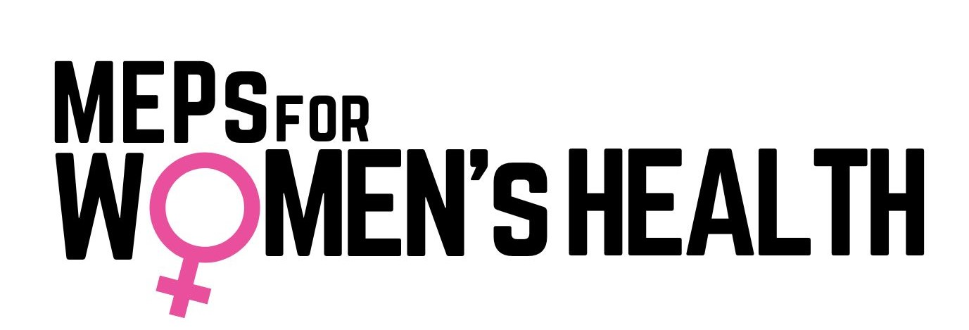

***Press release- content and text for social media***

**HEALTHY WOMEN - HEALTHY EUROPE**

*January 29th, 2025* - Today, the "MEPs for Women's Health “group was re-launched in the European Parliament. It is a cross-party group aimed at addressing the challenges in women's health across the EU. The initiative brings together Members of the European Parliament (MEPs) with a shared commitment to improving women's health policies, ensuring access to quality care, and promoting gender-sensitive healthcare systems throughout the EU.

The group's co-chairs, MEPs **Tilly Metz** (Green), **Sirpa Pietikäinen** (EPP), **Stine Bosse** (Renew), **Romana Jerković** (S&D) spoke at the inaugural event, outlining the mission and objectives of the initiative.

**Tilly Metz, Co-Chair, MEPs for Women's Health:** "Women's health must no longer be an afterthought. For too long, women’s health issues have been marginalised or misunderstood in research, policymaking, and healthcare provision. This initiative aims to change that. Our goal is to ensure that women's health is given the priority and the tailored solutions it needs. From reproductive rights to menopause care, we will be working to ensure that every woman in Europe has access to the care and support she deserves."

**Stine Bosse Co-Chair, MEPs for Women's Health:** "*I am so pleased that we now have an intergroup on women’s health. There are so many areas that we need to look further into. For example only four percent of what is happening in research globally is actually directed to women’s health and every other woman has experienced going to the doctor and not been taken seriously, so we obviously need to do a lot more, and I look forward to join that work.*

**Romana Jerkovic Co-Chair, MEPs for Women's Health: "**The launch of the MEPs for Women's Health represents an important step forward in ensuring that women's health is no longer overlooked in our policy agenda. Together, we represent a collective commitment to addressing the unique healthcare challenges that women face across Europe. As a member of the European Parliament, I believe advancing women's health **is not just a matter of social** justice, but also essential to building a more equitable society - one that must include a comprehensive Women's Health Strategy at the EU level."

**Sirpa Pietikäinen Co-Chair, MEPs for Women's Health:** *“ Women’s health has so far been neglected, starting from stem cells, different health mechanisms, research, gender typical symptoms and diseases, such as osteoporosis, reproductive health issues, memory disorders, some endocrine related diseases, as well as the different impact of pharmaceuticals in females. Besides this, quite often social and other societal factors that are affecting females and their health, such as single parenting or longer life spam, can be unseen, and thus there is a high risk of under understanding of women’s health and that women are under taken care of in our health systems. It is time to stop this. We need a common EU female health policy.”*

Women play a pivotal family, social and economic role. Sadly, women’s health issues are still overlooked at EU and national level. In the current geo-political climate, women’s health issues and challenges need to be at the forefront of all policies.

The MEPs for Women's Health group will focus on a wide range of priorities, including but not limited to:

* Increasing investment in women's health research and data collection
* Raising awareness on how diseases affect women differently
* Increasing participation of women in clinical trials
* Including sex and gender in healthcare professional education
* Addressing gender disparities in healthcare access and outcomes
* Dispelling digital health and health inequity
* Focusing on disease prevention
* Securing sexual reproductive health and rights
* Advocating for improved standards of maternal health services
* Tackling brain health and mental health issues affecting women across the life course
* Promoting cancer prevention and implementation of the EU Beating Cancer Plan
* Preserving the health of women engaged in a caring role
* Promoting active and healthy ageing
* Overcoming the gender pay gap and its long-term impact on women’s health
* Implementing work-like balance policies in line with the European Pillar of Social Rights
* Combatting gender-based violence and its impact on women’s health

The re-launch of this initiative signals a renewed commitment by the European Parliament to address the underrepresented and often overlooked health needs of women. It is expected to have a long-term impact on shaping policies that will benefit women throughout Europe.

**For more information, please contact:**

Women’s Health Secretariat - European Institute of Women’s Health, info@eurohealth.ie

### END