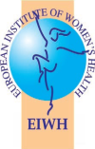

HEALTHY WOMEN, HEALTHY EUROPE
TOWARDS AN EU WOMEN’S HEALTH STRATEGY FOR EUROPE
TURNING VISION INTO ACTION

EIWH 2025 Impact Report – Key Highlights
The momentum for an EU Women’s Health Strategy has never been stronger At EU level, in its Roadmap for Women’s Rights and the 8 key principles of the Declaration on women’s rights annexed to the Roadmap, the European Commission (EC) Equality DG recognises the need to address women’s specific health challenges affirming its commitment to empower women and girls and fully realise a gender-equal society across Europe and the world. Together with the Roadmap, the 2025 report on gender equality in the EU will help frame the work for a new Gender Equality Strategy and serve as a compass towards greater gender equality in the EU.  At national level, three countries are leading the way with a dedicated Women’s Health strategy (Austria, Ireland and Netherlands). Other countries (France and Germany) are currently considering launching a Women’s Health strategy too. | 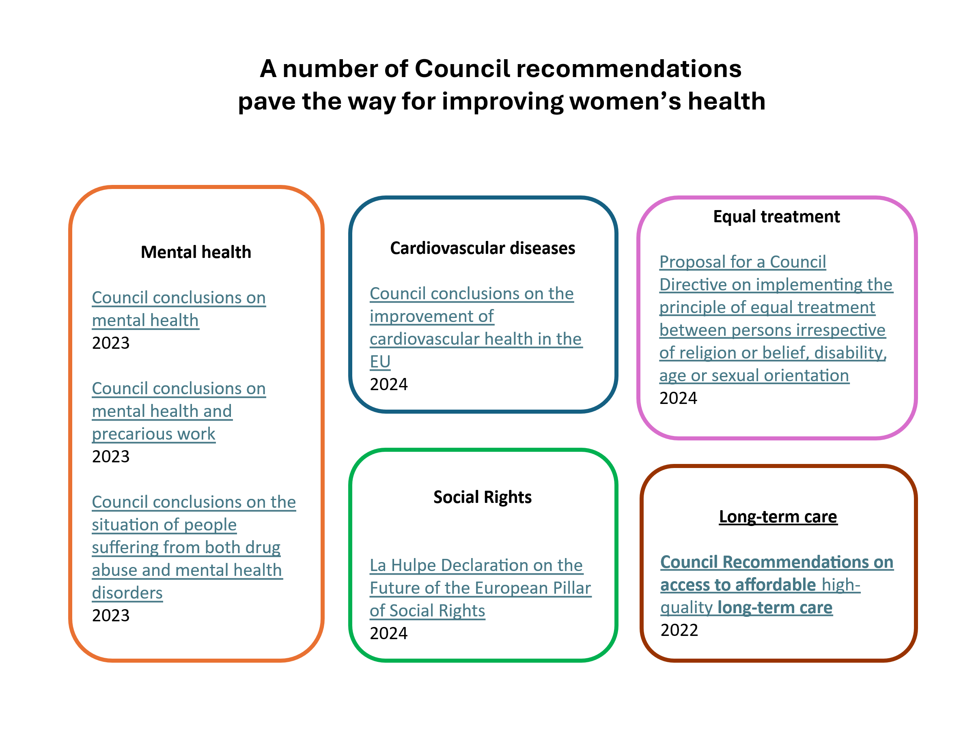

Highlights at a glance

P  O  L  I  C  Y | A  D  V  O  C  A  C  Y |  | - Launch of the MEPs for Women’s Health Interest Group(IG) in the European Parliament — establishing a permanent platform for advancing women’s health in EU policy.  - Organised Two successful roundtables for the MEPs for Women’s Health Interest Group followed up by IG receiving priorities in women’s health from over 80 organisations  - Young Women’s Health Group established — ensuring women aged 18–35 actively shape health priorities and policies.  - Flagship Framework Advanced: Towards an EU Strategy for Women’s Health supported by nearly 50 organisations, laying the foundation for a future Coalition for Women’s Health.  - High-Level Conference in Dublin (November): With the Irish Global Health Network and Women in Global Health, convened experts, advocates, policymakers, and women with lived experience to embed gender equity into EU health policy. Outcomes will directly inform the Irish Presidency of the EU.  - Launch the EU Partnership for Women’s Health with 50 partners.  - Launch of the EIWH EU Strategy for Women’s Health  - Amendments in Critical Medicines Act  - Recommendations on Pharma Package  - Submission to consultation on cardiovascular disease  - Submission on EU4Health Programme 2026  - Consulted by EIOPA  - Draft 2026 Action plan for MEPs for Women’s Health Interest Group  - Potential EU Parliament hearing on Women’s Health during Gender Equality Week, (November).
R  E  S  E  A  R  C  H | K  N  O  W  L  E  D  G  E |  | - Completed mapping of good practices in women’s health across six EU countries — providing evidence for policy transfer.  - Advanced leadership in major EU research projects:  - CBIG-SCREEN – equitable cancer screening.  - Spiomet4Health – PCOS & metabolic health.  - Real4Reg – patient-centred regulatory science.  - HPV-Faster – HPV vaccination acceleration among underserved groups of women and girls.
P  A  R  T  N  E  R  S  H  I  P  S |  | A  L  L  I  A  N  C  E  S | - Signed a collaboration agreement with WHO Academy (2026) to embed gender inclusiveness in e-health leadership training.  - Expanded leadership roles in major networks: EU Alliance for Cardiovascular Health (EACH), EU Vaccine Coalition, Sante HTA Network, HIV Alliance, Fertility Coalition.  - Deepened international collaboration with IWK Health (Canada) on a Canadian Women’s Health Strategy.  - Strengthened advocacy reach through new partnership to integrate inclusive health approaches.
E  U  R  O  P  E |  | I  N  T  E  R  N  A  T  I  O  N  A  L | - As one of the European Medicines Agency's eligible patients and consumers organisations, the EIWH is frequently consulted to assist in the identification of experts for specific matters.  - Contributed to EMA Patients’ and Consumers’ Working Party to integrate women’s health in regulatory processes.  - Rebecca Moore, EIWH Senior Researcher on advisory board , ECDC to embed gender dimensions into infectious disease prevention.  - EIWH Project Manager DR. Heidi Siller works on the HIV Alliance and represents EIWH on Expert group for Cancer Patient Organisation  - The EIWH is the Chair of the WHO Academy and leads the Patient and Communities of Interest Working Group. The mission of the Academy is to reach millions of learners with evidence-based and impactful lifelong learning that is accessible, innovative and accelerates achievement of global public health goals including the WHO Triple Billion Goals and the United Nations Sustainable Development Goals. I  - In 2023, the EIWH joined the WHO Civil Society Commission which mission is inter alia to strengthen dialogue, foster collaboration and provide recommendations to support WHO on its engagement with civil society at global, regional and national levels to achieve health for all.  - Peggy Maguire (EIWH Director General) co-Women’s Health Task Force, Dept of Health Ireland.

Looking ahead to 2026, EIWH will:
- Contribute to Irish Presidency events on women’s health.
- Continue work with MEPs for Women’s Health Interest Group
- Maintain existing partnerships and pursue new ones
- Continue contributions to EMA PCWP
- Continue contribution to SANTE HTA stakeholder network
- Continue work with WHTF Ireland
- Continue work with WHO ACSO
- Continue work with WHO Academy
- Strengthen the Coalition for Women’s Health with 50 partners.
- Drive adoption of the EU Strategy for Women’s Health.
Implement the WHO Academy partnership.
- Expand transatlantic collaboration with IWK Health Canada
- Strengthen relationship with Women in Global Health
- Disseminate findings from major EU research projects to influence national and EU health systems.
Work on the following to identify opportunities for input and influence
EP report on the Annual Budget
EP reports on the Multi- Financial Framework (MFF) and future instruments.
- R&I framework FP10 and Competitiveness Programme
- External Action Instrument Global Europe
- EU4Health Programme
Gender Equality Strategy (set for publication around March 8)
Cardiovascular Plan

Awareness raising and communication hooks: International Days (not Exhaustive)
- International Day of Women and Girls in Science (February 11)
- HPV Awareness Day (March 4)
- International Women’s Day (March 8)
- World Health Day (April 7)
- EU immunisation week (April 25)
- European Week Against Cancer (May 25-31)
- International Day of Action for Women’s Health (May 28)
- World Alzheimer Day (September 21)
- World Contraception Day (September 26)
- World Mental Health Day (October 10)
- Cervical Cancer Elimination Day (November 17)
- Antimicrobial Awareness Day (AMR) (November 18)

Through strategic, evidence-based advocacy, and broad alliances, the EIWH continues to turn vision into action — ensuring that women’s health becomes a central pillar of EU health policy. The organisation’s work in 2025 has laid a strong foundation for 2026 and beyond, marking a decisive step toward a comprehensive EU Women’s Health Strategy that serves every woman and girl in Europe.

The European Institute of Women’s Health (EIWH) is a non-governmental organisation dedicated to advancing the health and well-being of women and girls across Europe. EIWH has worked to ensure that sex and gender are systematically integrated into health policy, research, regulation, and practice at both European and national levels. Acting as a bridge between policymakers, researchers, healthcare professionals, and civil society, EIWH brings women’s voices and lived experiences directly into the heart of decision-making. The organisation is recognised as a trusted expert body in EU health debates, advocating for equity, inclusiveness, and a life-course approach to health that benefits not only women, but society as a whole.

The Roadmap will serve as a compass to answer the EIWH’s EU Women’s Health Strategy priorities: freedom from gender-based violence, the highest standards of health (including women's access to sexual and reproductive health and rights in full respect of the Treaties, and promotion of gender-sensitive medical research, clinical trials, diagnostics and treatments), equal pay and economic empowerment, work-life balance and care, equal employment opportunities and adequate working conditions, such as by eradicating the gender employment gap, eliminating sexual harassment in the world of work, quality and inclusive education, political participation and equal representation, institutional mechanisms that deliver on women's rights. https://ec.europa.eu/commission/presscorner/detail/en/ip_25_681

